Town of Macklin Official Community Plan

TABLE OF CONTENTS
SECTION 1: INTRODUCTION 2
1.1 WELCOME TO THE TOWN OF MACKLIN 2
1.2 MAP OF THE TOWN OF MACKLIN 4
1.3 ENABLING LEGISLATION 5
1.4 BEYOND LEGISLATIVE AUTHORITY 5
1.5 PURPOSE OF THE MACKLIN OFFICIAL COMMUNITY PLAN 5
1.6 COMMUNITY BACKGROUND AND SOCIO-ECONOMIC PROFILE 6
SECTION 2: COMMUNITY VOICE AND VISION 11
2.1VISION FOR THE TOWN OF MACKLIN 11
2.2 THE COMMUNITY OF MACKLIN GOALS 12
SECTION 3: TOWN OF MACKLIN LAND USE POLICIES 12
3.1 GENERAL POLICIES FOR NEW DEVELOPMENT 12
3.2 SOCIAL PRIORITIES FOR MACKLIN 15
3.3 RESIDENTIAL DEVELOPMENT 18
3.4 COMMERCIAL DEVELOPMENT 22
3.5 INDUSTRIAL DEVELOPMENT 25
3.6 TRANSPORTATION NETWORKS 28
3.7 INFRASTRUCTURE: ASSET MANAGEMENT PLANNING 31
3.8 COMMUNITY SERVICE AND RECREATIONAL LANDS 34
3.9 HERITAGE AND CULTURAL RESOURCES 39
3.10 ENVIRONMENTALLY SENSITIVE AREAS 41
3.11 FUTURE URBAN DEVELOPMENT 43
SECTION 4: ADMINISTRATIVE TOOLS 45
4.1 ACTION PLANNING 45
Appendices 52
APPENDIX “A” – TOWN OF MACKLIN FUTURE LAND USE MAP 53
APPENDIX “B” – REFERENCE MAPS 54
APPENDIX “C” – TOWN OF MACKLIN INFRASTRUCTURE CAPACITIES 61

Section 1: INTRODUCTION
- Welcome to THE TOWN OF Macklin
The Town of Macklin is located in the North West Resource Corridor Planning District with a 2011 Census population of 1,415. Situated in the Rural Municipality of Eye Hill # 382, Macklin is located 226 kilometers (kms) from Saskatoon, 30 kms from Provost, Alberta, 122 kms from North Battleford and 110 kms from Lloydminster. With a distance of 5 kms, Macklin has close proximity to the Saskatchewan- Alberta border.
Macklin is a community that provides many health and educational facilities, recreational amenities, and commercial services to local and district residents. With locational advantages and ample opportunities for work and play, Macklin is a great place to raise a family, retain long-term residents and do business.
Macklin is viewed as one of the regional "centres" of the District providing goods and services for the surrounding population as well as containing numerous of commercial and industrial enterprises.
This Section is referred to as the Town of Macklin’s Official Community Plan (OCP) and will address the Town of Macklin’s residential, parks and open space, community service, industrial, commercial and agricultural land uses within the Town’s corporate boundaries. It will discuss the current land use issues and provide policies to enhance the quality of life for residents in Macklin and district. The Plan will address such items as:
- Identification of sufficient land to address the long-term physical growth of the Town;
- Guiding growth in a planned manner so that public costs of infrastructure, streets and other services are minimized; and,
- Incorporation of other development initiatives and issues into the Plan, such as business development, transportation, parks and recreation, and engineering services.

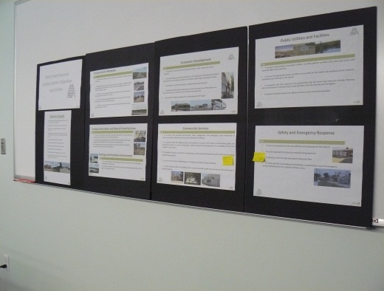
The Planning and Development Act, 2007, provides the legislative framework for the preparation and adoption of a District Plan and Official Community Plan. Within the Act, Section 102 (12-15) allows for a municipality to have an Official Community Plan in accordance with a District Plan as long as it is consistent with the District Plan. The Official Community Plan and District Plan are consistent and directly related to one another. Macklin understands the benefit of working at a District level though due to its size and unique characteristic also requires goals and policies directly related to the Town.
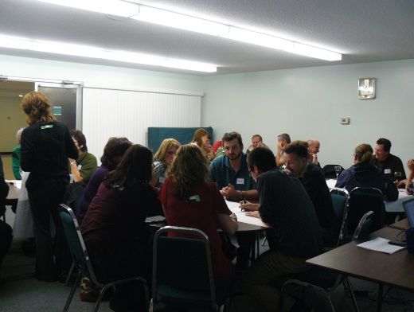
This OCP is intended to provide direction as to how the Community of Macklin envisions the area growing and developing over the next ten to twenty plus years. This Plan shall be reviewed regularly, will facilitate the development and ongoing sustainability of the community by enhancing the social, physical, economic and cultural well-being for Macklin’s residents.
This “Plan” is a community based effort. Planners were assisted by a widely representative group from the region. Participants included Town Councilors, residents from Macklin and from outside of the Town, and representatives from adjacent Rural Municipalities.
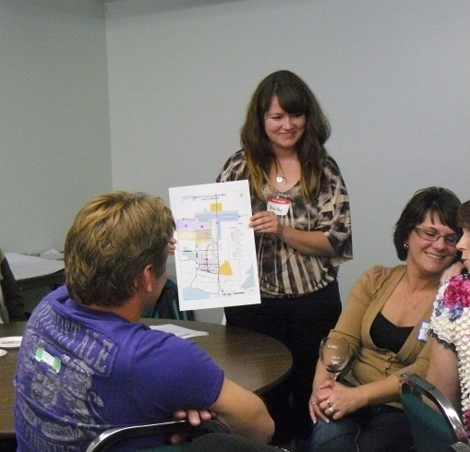
A community questionnaire was mailed to the residents and businesses in February 2011. A Council meeting was held on April 11, 2011 and a community meeting was held on May 22, 2012. Information gathered from the community created the Vision statement which then led to the goals and objectives, not only for future growth, but more importantly, in identifying the areas where development would enrich the quality of life in Macklin.
Site specific details such as building yard requirements, permitted and conditional uses, will be provided in the Town of Macklin Zoning Bylaw which has been adopted to recognize the policies and the intent of this Official Community Plan.
The most important map will be the Town of Macklin “Future Land Use Map” (Appendix A) which lays out land uses for the entire Town and it is attached to, and forms part of, this Bylaw. This map is a general illustration of land uses with the express purpose of indicating the spatial relationship between many different land uses and activities.

- MAP OF THE TOWN OF MACKLIN
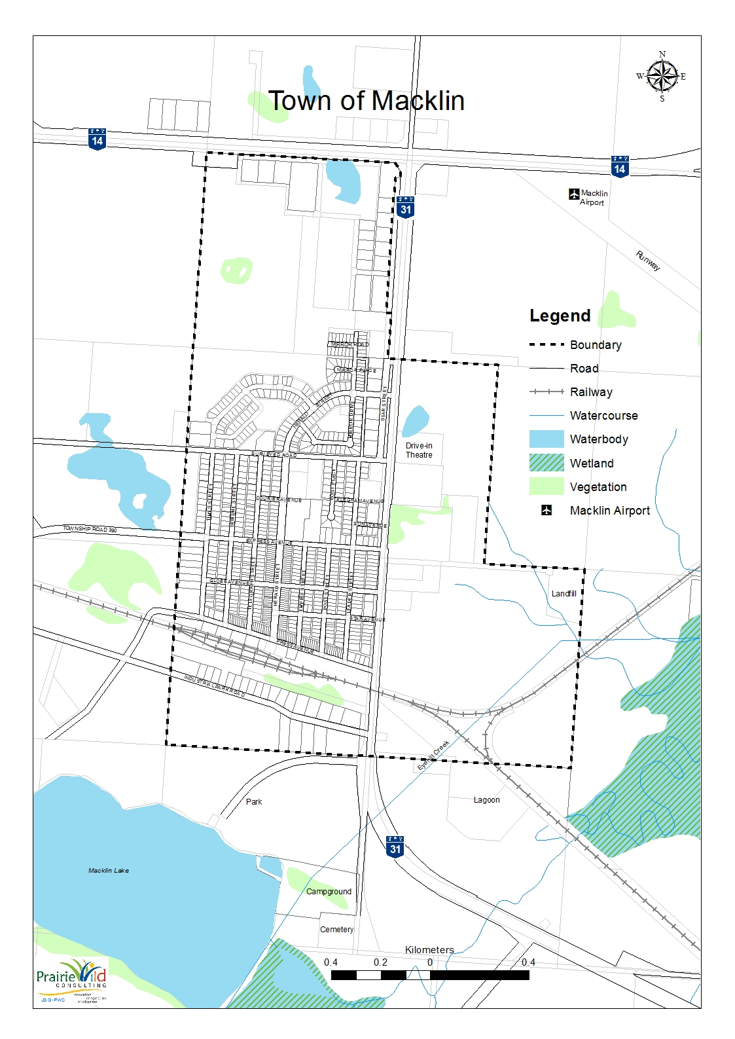
- ENABLING LEGISLATION
The Planning and Development Act, 2007, provides the legislative framework for the preparation and adoption of an Official Community Plan. The Plan addresses such items as future land use, development and other matters of community concern. This Plan is intended to guide the Town for a period of twenty to twenty-five years.
- BEYOND LEGISLATIVE AUTHORITY
The Town of Macklin Official Community Plan is derived from a participatory process with the involvement of many residents, stakeholders and other community members. The non-legislative authority for the Plan is the capacity-building and partnership opportunities that have been realized as a result of this process their direct correlation to sustainable growth, which is considered a priority to the Town of Macklin.
- PURPOSE OF THE MACKLIN OFFICIAL COMMUNITY PLAN
An Official Community Plan, as deemed in Saskatchewan under The Planning and Development Act, 2007 states:
The purpose of an Official Community Plan is to provide a comprehensive policy framework to guide the physical, environmental, economic, social and cultural development of the municipality.

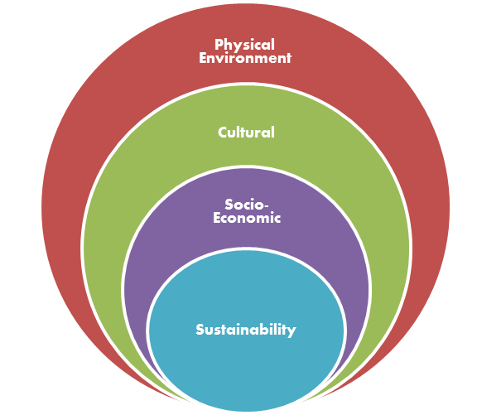
The Planning and Development Act, 2007 and The Statements of Provincial Interest, provides the legislative framework for the preparation and adoption of the Macklin Official Community Plan. Items addressed in a comprehensive plan include: future land use, and development. In addition, this Plan will include provisions for administration, amendment and repeal of the Plan.
The Macklin Official Community Plan is intended to guide the Town of Macklin to promote orderly and sustainable development. This Plan will reduce uncertainty for both the public and private sectors with respect to the future use of land by development practices that are compatible with the land base and environment in the Town.
The Town shall in conjunction with the adoption of this Plan, amend in accordance with The Planning and Development Act, 2007, their respective Zoning Bylaw as required to be consistent with the policies and provisions of the Macklin Official Community Plan. The Plan responds to the requirements of the Act by providing policies based upon “Community Goals.” The day-to-day decisions based upon these goals, objectives and the policies in this Plan are intended to promote orderly and sustainable development.
Findings from the consultative processes, together with technical research, have focused the Plan on the potentials and issues residents and land owners identified as of prime importance for the future of the Community. Together, with the North West Resource Corridor Planning District, there is the opportunity to take an inter-municipal approach to:
- Attract new residents and businesses to the Town and District to support local amenities and increase tax base;
- Take advantage of the existing infrastructure, central location, community assets; and,
- Market economic opportunities and natural features – recreational, waterbodies, commercial and industrial.
- COMMUNITY BACKGROUND AND SOCIO-ECONOMIC PROFILE
Community Background
The Town of Macklin is located in the RM of Eye Hill No. 382 and is situated along the Highways #31 and #14. Macklin was settled in 1909 and incorporated in 1913. It was named after the famous executive of the Winnipeg Free Press. Currently, all of the streets within the community are named after well-known Canadian journalists.
Some of the buildings and services built in Macklin’s early years included a general store, hotel, post office located a mile out of Town, Memorial Community Arena, new church, and other stores. Something that is unique to Macklin and its geographic location is the number of disasters to hit the community. These include a miniature cyclone in 1909 and a fire that wiped a lot of the built structures.
Today Macklin is a growing community with a 2011 Census population of 1415. There are a number of businesses and it is surrounded by agricultural and oilfield industry. Macklin provides a number of community amenities and services including though not limited to a Macklin and District Health Hentre; Macklin (k-12) School; Communiplex; Regional Park and is home to the World Bunnock Championship that attracts people from all over the world.
Population trends
The total population of Macklin in 2011 was 1415, an increase of 6.0 percent. According to data collected by Statistics Canada, shown in Table 1, the population decreased 3.1 percent between 1991 and 2006. However, the Province of Saskatchewan has seen recent growth between 2006 and 2010 at a rate of 7.2 percent and much growth has been seen in communities around large cities. Based on a modest growth rate of 2 percent each year, similar to the province, population projections have been made for the years of 2020 and 2040. By utilizing this growth rate, Table 1 suggests that the population of Macklin may hit approximately 1658 by 2020 and approximately 2464 by 2040.
Table 1: Town of Macklin Population 2001-2011 and Projected Growth
Year | 2001 | 2006 | 2011 | 2020 Projected based on a 2% annual growth rate | 2040 Projected based on a 2% annual growth rate
Population | 1330 | 1290 | 1415 | 1658 | 2464
Source: 2011 Census of Canada, 2006 Census of Canada
Age and Gender Distribution
There is a high percentage of youth between the ages of 10-14 and 20-24. This illustrates the community may be attracting young families. The overall median age of Macklin is 31.9. Of all Macklin residents over the age of 15, 790 people were third generation while 15 people reported as being first-generation.

Source: 2011 Census of Canada
Mobility
In 2006, the total population 5 years and older was 1195. Of this population, 760 people lived at the same address as they had 5 years prior. 230 people had moved within the same municipality, and eighty (80) people had moved to a different municipality. Figure 2 shows that 64% of Macklin residents have lived in the community for at least five years at the same address.

Source: 2006 Census of Canada
Language
In the community of Macklin, 98.6% of the population had knowledge of English, 0% knew French and 0.7% knew both English and French. The language most spoken at home is English with 97.1% of the population, 0% spoke French at home and 2.2% spoke a non-official language.
Dwelling Characteristics
As of 2011, there were 1360 private households. Of the 1360 households, 525 identified by structural type. 79% of households were single-detached, 16% were other dwellings, 10% were row housing, 4% were movable dwellings, 3% identified as apartments less than five stories, 2% semi-detached houses and 1% were apartment/duplexes.
The average household size in Macklin is 2.6 occupants. This is slightly higher than the Saskatchewan provincial average of 2.4 occupants. In 2006, the average value of a dwelling was $109,438, while the Saskatchewan provincial average was higher, at $132,111.
Education Level
Figure 4 describes the level of education attained for those aged 15 years and older in Macklin, divided as a proportion of total by gender. Of the 995 residents aged 15 years and older, 27 percent have achieved their grade 12 or higher. This is below the provincial average of 70 percent. 30 percent have achieved a trade certificate or diploma, college certificate or diploma or some level of university. Of the 30 percent, 135 were male and 175 were female.

Source: 2006 Census of Canada
Economic Trends
Employment
In 2006 there were 995 people 15 years and over in Macklin and 69% (690 people) are considered to be in the labour force. The employment rate of those in the labour force was 67.8% and the unemployment rate was 2.9%. At that time, the Saskatchewan unemployment rate was 5.1%.
Mode of Transportation
The total employed labour force 15 and over with a usual workplace or no fixed workplace address in Macklin is numbered at 625. This characteristic excludes residents in the work force who work at home. 500 of the people reported driving a motor vehicle of some sort to work; 35 reported going to work as a passenger; 80 people walked or biked to work; and, 10 reported a different mode of travel. This states that approximately 80 percent of Macklin’s employed work force travels to work by means of something other than a motorized vehicle.
In 2006, 245 people reported to work at their usual location, 40 worked in a different municipality and 140 worked in a different province. Long distance commutes limit the ability of residents to travel by a method other than a vehicle.
Occupation
Table 3 shows Macklin’s work force by occupation, with 25% working in trades, transport and equipment operations, 24% working in sales and service and 14% working in primary industry.

Table 3: Occupation in Macklin in 2006
Occupation | Total | Male | Female
Management | 50 | 35 | 15
Business; finance and administration | 80 | 25 | 55
Natural and applied sciences and related | 0 | 10 | 0
Health | 30 | 0 | 25
Social science; education; government service and religion | 20 | 10 | 15
Art; culture; recreation and sport | 0 | 0 | 0
Sales and service | 165 | 40 | 120
Trades; transport and equipment operators | 175 | 150 | 20
primary industry | 95 | 90 | 10
Processing; manufacturing and utilities | 60 | 60 | 0
Source: 2006 Census of Canada
Work Force by Industry
Figure 5 breaks down the Macklin labour force by Industry. In 2006, the top six occupations as a proportion of total employment were agriculture and other resources (36%); retail trade (13%); business services (11%); wholesale trade (8%); finance and real estate (7%); and health and social services (7%).

Source: 2006 Census of Canada
Income
In 2006, the median family income for the Town of Macklin was $27,437. The median family income after tax of residents 15 and older was $24,333 placing Macklin above the provincial average of $21,679.

Section 2: COMMUNITY VOICE AND VISION
Below is the vision and goals for the community of Macklin. These are reflective of the voice of community members and what they hope to strive for 25+ years into the future.
- vISION FOR THE TOWN OF Macklin
In 2039…
Macklin is a progressive community with double the population. It is a place for all ages, providing multiple services for residents and visitors. The Town is proactive with growth and development and ensures it is managed in a sustainable manner. The Community is proud and inclusive of all.
Agriculture, oil and gas industries are balanced within the Community and area and provide employment opportunities. Our natural areas, including our Regional Park, is protected from contamination and highlighted as a key amenity to the District for residents and visitors.

- tHE cOMMUNITY OF Macklin gOALS
- Providing a variety of services and amenities including health, education, recreation, culture, and housing to ensure a positive quality of life for residents.

- Offering a continuum of housing including rental, affordability, transient and senior.

- Pursuing revitalization efforts of the downtown core to attract new businesses and people spending money locally.

- Collaborating with the RM of Eye Hill and the wider district on regional initiatives such as tourism and recreation.

- Promoting safe local streets and highways, exploring other options to do this including slower speeds through Town, twinning of the Highways, traffic lights and a pedestrian bridge or underpass to the Communiplex.

- Preserving the natural surroundings while also providing more green space for residents and visitors.

- Promoting the Regional Park through a tourism plan or initiative including signs and brochures that highlights the asset in the region.

- Exploring alternative energy uses within the community and for commercial and industrial uses to reduce the ecological footprint of the Town.

Section 3: TOWN OF MACKLIN LAND USE POLICIES

3.1 GENERAL POLICIES FOR NEW DEVELOPMENT

The Town will strive, through this Official Community Plan, to provide policies related to land use, transportation, servicing and other aspects of planning that are consistent throughout the Town.

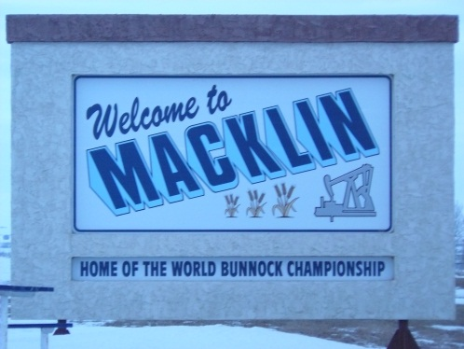
Macklin shall have a compact form, mix of uses and densities that allow for the efficient use of land, infrastructure and public facilities. This OCP will designate an adequate inventory of suitable lands to attract a broad range of residential, business enterprise, recreation, institutional, and industrial development to meet anticipated long-term need.

In managing change, the Town will build and renew a comprehensive, integrated and long-term Asset Management Plan so that the impact of growth will not place an undue strain on municipal infrastructure or public service facilities.

Primary consideration shall be given to a proposal’s conformity with the over-arching policies in this Plan and the North West Resource Corridor District Plan.

A proposal shall be denied when it is detrimental to the health, safety, general welfare of persons residing or working in the area, or incompatible with existing or proposed land uses in the vicinity.

Major deviations to the OCP design and policies shall require a formal amendment based on research and evaluation. Amendment Bylaw No. 05-2016.

This OCP will ensure compliance with the Building Bylaw to ensure that dwelling and buildings are constructed and maintained to acceptable and safe standards, as defined in The National Building Code of Canada.

Appropriate development standards for the various uses relating to landscaping, signage, parking, building setbacks, and other relevant standards shall be administered through the Zoning Bylaw.

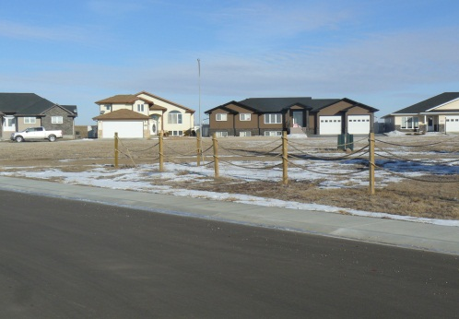
Development and new subdivisions shall be encouraged to locate where servicing and infrastructure are in place, or planned, to support the intensity and type of development. Development shall strive to avoid any major alterations to drainage, landscape or other natural conditions and shall be required to mitigate on and off-site impacts.

Cumulative effects, land fragmentation, best management practices, innovative procedures, development phasing, route modification, alternative construction techniques and impacts on municipal servicing shall be considered when reviewing all developments and their compliance with the Future Land Use Map.

Planned development will help to increase land values, reduce waste of land resources, minimize public expenditure in service provision, and recognize significant community features in maintaining the small Town lifestyle.

Rezoning proposals for development will be considered based upon the following criteria:
- impact on surface and groundwater;
- cost effective relative to the provision of services;
- sewage disposal impacts and pollution potential;
- integration with natural surroundings and adjacent land uses;
- provision or greenspace and trails;
- provisions for public safety; and,
- other criteria which support a sustainable community.

Public safety and health requirements shall guide all development. The Town shall ensure that Emergency and Responsiveness Plans are current and reflect changes in land use or activities.

Activities that generate litter, unacceptable noise, air emissions, dust, liquid and solid hazardous wastes, or that store regulated quantities of hazardous materials shall be strictly regulated and, if permitted, shall be located well away from residential uses and other natural or developed features or areas where residents may be impacted by pollution.

Vacant properties and open space areas outside maintained parks shall be kept free of litter and debris, abandoned vehicles, derelict structures, polluted soil, groundwater, and other pollution and nuisances.

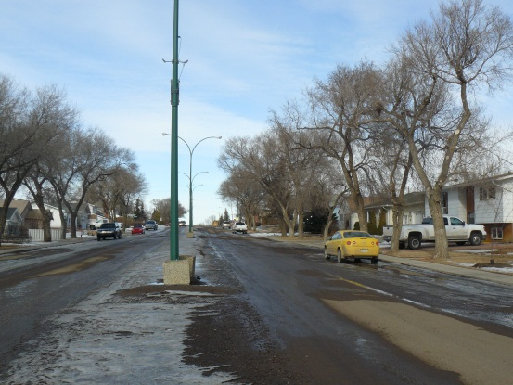
Development shall be integrated with the natural surroundings and should complement the surrounding community design, landscape and vegetation. Existing trees and vegetation shall be retained where possible and incorporated into site planning. A variety of native trees and vegetation shall be encouraged to minimize maintenance and water use.

New development shall be prohibited in a flood way of the 1:500 year flood elevation of any watercourse or waterbody. If a new building or alteration is approved in a flood prone zone, flood proofing to an elevation 0.5 meters above the 1:500 year flood elevation is required. Flood prone areas for the Town of Macklin are identified in a Reference Map provided in Appendix “B”.

The Saskatchewan Water Security or other appropriate government or private sector consultants will be utilized as a source of technical advice regarding flood levels and flood proofing techniques.

Development proposals in flood plains areas shall be referred to Saskatchewan Water Security Agency for review prior to approval. A site specific legal land survey including contour lines shall be provided by the proponent at the time of proposed development.

Sustainable policies and sustainable building design criteria such as the use of alternative building methods, recycled building products, renewable energy sources, solar orientation, innovative waste water and water reduction strategies shall be promoted. Building materials and construction methods that conserve energy and reduce long-term operating costs shall be encouraged.

Development and subdivision plans that offer design features such as alternative energy sources, innovation in health, or environmental responsibility shall be encouraged where they are consistent with OCP policies.

The Town recognizes the importance of implementing land use controls that identify and preserve pipeline rights-of-way. Public and pipeline safety shall be taken into consideration in the development planning and design. Development along pipelines shall be subject to the following:
- Any development involving pipeline and/or power line transmission rights-of-way shall be sited to comply with all relevant Federal and Provincial legislation. Setbacks from pipelines and other utility corridors shall be in accordance with appropriate corporations. Refer to “Land Use Planning for Pipelines publication by Canadian Standards Association (CSA) PLUS663”, which may be amended from time to time;
- Setbacks from the edge of the pipeline easement shall be 12.0 metres (39 ft) except for where there is more stringent Federal and Provincial regulations in which those regulations apply;
- The National Energy Board has designated a setback area of 30 metres (98 ft) on either side of a pipeline in which, subject to exceptions for such things as normal agricultural activities, anyone proposing to conduct a ground disturbance/excavation, must:
  - Ascertain whether a pipeline exists;
  - Notify the pipeline company of the nature and schedule of the excavation; and,
  - Conduct the excavation in accordance with such regulations.
- Development proposals which may impact the pipelines within 200 metres (656 ft) of the Town’s pipeline corridor shall consult with the pipeline operators as part of the formal land use planning and application process, and prior to submitting a subdivision or development permit application. Amendment Bylaw 05-2016.
3.2 SOCIAL PRIORITIES FOR MACKLIN
The Town of Macklin is a friendly community with a small town charm. The people are welcoming and there are a number of clubs and organizations available to join for all ages. There are also many services and amenities in Macklin such as health care, education, accommodation, sports and recreation, culture, restaurants, shopping and more. There is potential for population growth and opportunities for commercial and industrial expansion.
The main priority for the Town is to provide a place that can be called home. Macklin wants to ensure the safety and well-being of its residents, provide a variety of services and businesses in an efficient manner and to create an aesthetically appealing town with a sense of place to attract new residents and visitors.

Objectives
- To communicate Town events and initiatives through various methods of communication.
- To provide opportunities for community members to participate in Town development and activities.
- To ensure developments are safe and unharmful to residents and neighbouring land uses.
- To maintain and sustain the services provided to our community members and ensure they are accessible to all.
- To continue to maintain and provide health and emergency services.
- To work collaboratively with neighbouring municipalities to attract health care personnel and doctors.
- To create update emergency service and evacuation plans regularly.

Social Policies

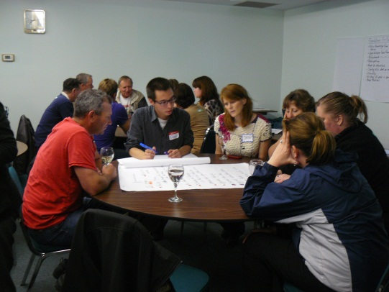
.1 The Town will strive to enhance local communication through an open and inviting process that brings the public together with municipal officials including regular reports to the community and forums allowing public participation in community issues.

.2 The Town may establish ad hoc advisory committees to solicit input on social, cultural, economic, and environmental issues and to provide a local public process that prioritizes community projects when opportunities for community development arise.

.3 The Town will advocate for the integrated planning and provision of services, programs and facilities on a cooperative basis, involving appropriate agencies, groups and individuals to achieve accessible, appropriate, and flexible service provision for all residents irrespective of their physical, economic, social or cultural characteristics.

.4 The Town will ensure all developments are safe, accessible to all and are conducive to social interaction by encouraging barrier free access design and locational considerations.

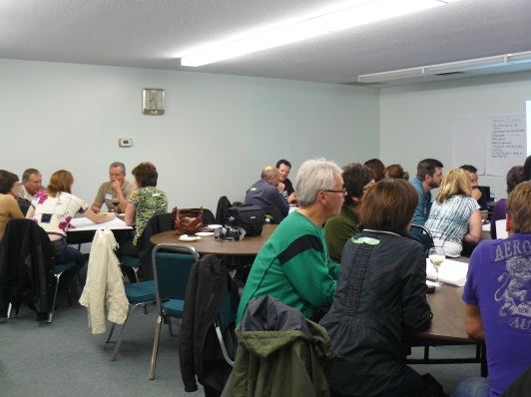
.5 The Town will identify social needs and plan service delivery by working with government departments, non-profit agencies, or by forming partnerships to address social needs on an on-going basis to:
    - identify and pursue the programming needs for youth, seniors and families through community input, and
    - improve housing affordability and choice in order to stabilize family and community life.

.6 Residents shall be given the opportunity to pursue community building initiatives with appropriate support and encouragement when planning community services, programs, facilities, neighborhood environments or other matters that affect their quality of life.

.7 The Town will ensure development enhances the physical, social, and cultural well-being of residents through support for the arts, culture, recreation, library, fire, police, education, social programs and health services to meet present and future needs.

Public health and safety Policies

Public safety and health requirements shall guide all development. The Town shall ensure that Emergency and Response Plans are current and reflect changes in land use or activities. As well, all firefighting requirements will be considered as a part of every re-zoning application, subdivision review and servicing agreement.

Emergency planning needs to be undertaken before an event to identify risk and to research risk reduction measures that lower the probability of an event even occurring. An understood and practiced plan needs to be maintained.

The Town is encouraged to utilize FireSmart principles for subdivisions planned within and adjacent to potential fire hazard areas.

Emergency service and evacuation plans shall be reviewed annually to ensure the most up to date information is provided within the document.

The Town shall work with the local RCMP to ensure their presence remains within the Community.

The Town will work collaboratively with neighbouring municipalities to ensure emergency service delivery is maintain through the Town and region.

The Town along with surrounding municipalities will continue to cooperate on joint health care initiatives and attracting health care professionals and personnel.

Macklin is located along an active rail line transporting material which also includes hazardous material through the community. The Town shall work with the respective rail agencies to comply with any adopted set of recommended development guidelines and setbacks for residential development adjacent to the rail right-of-way.

3.3 RESIDENTIAL DEVELOPMENT
There have been a number of new houses built in the Town of Macklin, including townhouses, seniors housing and transitioning mobile home parks to multi-family dwellings. The Town would like to continue to provide diversity in housing so there is a balance and range of demographics in the Town. A shortage of rental units has been identified. Providing more rental accommodations is a priority for the Town. The Town would like to explore options and work with public and private partners to develop this type of accommodation.
The Town on Macklin wants to ensure residential development within the Town and any expansion of such development is placed in a compatible way with compatible uses. The Town encourages infill residential development in order to increase efficiencies by utilizing existing infrastructure. Having a range of housing will give the Town the ability to attract a diverse range of residents, in which they can call Macklin their home.

Objectives
- To diversify the supply and emphasize choice when providing a full mix and range of housing types that respond effectively to the needs of different incomes, ages, and interests.
- To maintain a high quality of development and style compatibility in residential areas through phased development in an efficient, sequential and staged manner.
- To encourage the infilling and selective redevelopment of presently vacant or under-utilized lots to maximize existing municipal services.
- To avoid possible land use conflicts between residential uses and incompatible, non-residential uses.
- To provide a comparable level of utility and public amenity services to all residential areas.

POLICIES

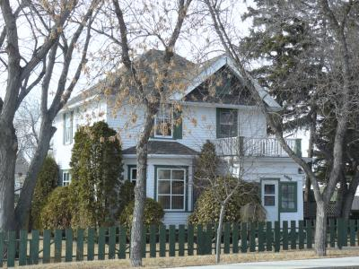
An efficient Town form will encourage a diversity of housing and site form in new residential areas, facilitating infill development, and providing for additional multi-unit residences, and allow for higher density residential development.

A variety of housing styles, types of ownership, and choice of lot sizes shall be encouraged to provide greater housing alternatives in Macklin, notably the need for rental accommodation.

The Town shall work with private and public partners to attract housing development specified for short and long term stay to accommodate transient workers and visitors.

New residential areas shall be developed and integrated with existing development in a manner that facilitates provide linkage to the community, efficient servicing, provides access to schools and adheres to appropriate development standards to ensure an equitable quality of life for all residents.

In areas where land is re-developed, or infilled for residential use, the full range of residential options shall be explored in determining the best product for the specific redevelopment. Infill shall be encouraged in existing residential areas.

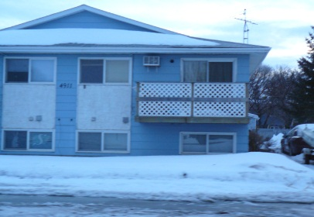
The Town shall, together with the Macklin Housing Authority, pursue opportunities to provide affordable housing options to the Community. It is important to maintain a supply of rental housing of various types in order to meet a wide range of requirements for a variety of household types.

Special needs housing shall be integrated into existing areas. Affordable housing incentives and residential development for seniors’ complexes shall be encouraged to locate in close proximity to services and community amenities. The provision for outdoor common areas shall be explored within these complexes.

Private and public special care homes, child and adult day care, and other forms of supportive housing and tenure (i.e. condominium ownership) shall be encouraged throughout the Town.

Residential development shall occur where municipal services are present or where they can be economically extended in order to maximize the efficiency of existing infrastructure.

New residential development proposals should be guided by Comprehensive Development Reviews and should indicate:
- future major roads;
- drainage systems and improvements required to meet non-agricultural drainage requirements;
- major open space (including unique physical) areas;
- cultural and archaeological significant areas;
- areas requiring protection through buffering or other means;
- major hazards such as flooding, areas of high water table, and slope lands;
- phasing of development; and
- include studies and reports from professional engineers and planners.

The Town may acquire and subdivide land for residential purposes where there is a need to expedite land for future expansion. Rezoning from another land use district to a residential district will be considered where servicing can be economically and safely supplied to a standard equal to the remainder of Town.

Non-residential development will not be allowed in residential areas except for developments that accommodate municipal services and institutional uses compatible with the residential area. Parks, recreational and institutional uses, such as schools, churches, childcare facilities, seniors housing and nursing homes shall be accommodated in residential areas.

A higher proportion of multi-unit housing would enhance land use efficiency and provide more affordable options. Multi-unit residential sites shall be designed to be compatible with land uses in the surrounding area. Multi-unit housing types range from duplexes to fourplexes, townhouses, and apartment blocks and shall be permitted in residential areas, with siting criteria as follows:
      - located, where possible, close to community facilities, educational and medical facilities, commercial areas and/or places of employment;
      - located, where possible, on sites having access to a major arterial street; or,
      - located on the periphery of single-family dwelling areas.

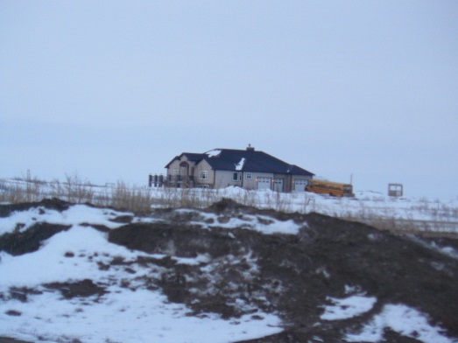
A limited number of residential acreage developments shall be encouraged to locate on existing municipal roadways within the corporate limits of the Town. These acreages shall occur in an orderly and sustainable manner compatible with differing land uses and shall minimize agricultural land consumption and severance. Residential acreage development shall be responsible for their respective on-site servicing and development costs. The Town may offer hook-ups to water lines where feasible.

Home-based businesses will be accommodated provided that they are clearly secondary to the principal residential use of the dwelling unit, compatible with the surrounding residential area, and not of a size or scale that would affect the viability of the Town Centre.
IMPLEMENTATION
The Zoning Bylaw shall include the following residential zoning districts: These Districts have a variety of permitted uses that are allowed within the Town of Macklin and the Zoning Bylaw will stipulate the requirements for each type of development.
R1- Residential Single Dwelling District | The purpose of the Residential District (R1) is to accommodate primarily single family detached residential dwellings.
R2- Residential Multiple Dwelling District | The purpose of the Residential Multiple Dwelling District (R2) is to accommodate a variety of high density residential development including single detached residences, semi-detached residences, townhouses and multi-unit dwellings.
RMH – Residential Mobile Home District | The purpose of the Residential Mobile Home District shall be to accommodate mobile home park development in a concentrated manner.
RA – Live/Work Residential Acreage District | The purpose of the Residential Acreage District (RA) is to accommodate clustered acreage residential development and subdivision proposals on a multi-site basis within the Town.

3.4 COMMERCIAL DEVELOPMENT
The Town of Macklin provides a number of core services and retail activities in the Town Centre. There is opportunity to work with local businesses and the Chamber to revitalize the core, providing the ability to attract new businesses. Along Highways #31 and #14 is also an opportunity for highway commercial development to provide a number of regional businesses and services.

Objectives
- To support existing businesses and uses and welcome new commercial development to the community including home-based businesses.
- To work with the Town Council and other business agencies to promote Macklin as a regional retail and service commercial centre.
- To promote an attractive and commercially viable Town Centre business area by encouraging the concentration of commercial, social and cultural activities in the Town centre.
- To ensure there is sufficient commercial land available for a variety of commercial development.
- To raise the profile of the highway commercial areas for expanded commercial use.
- To promote the locational advantages of the Town as a premium choice for industrial and commercial development.

Policies

The Town shall promote economic development and competitiveness by providing for an appropriate mix and range of employment including industrial, commercial and institutional uses by ensuring the necessary infrastructure is provided to support current and projected needs.

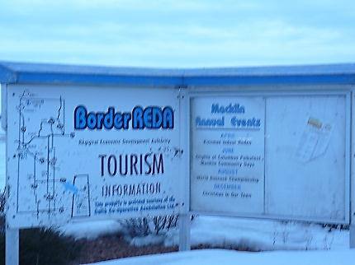
The Town shall continue working with an economic development organization, the Chamber of Commerce and other business agencies to promote the Town as a regional retail and service commercial centre and to advocate Macklin’s role in regional development.

Economic development opportunities that diversify the economic base by providing a range and choice of suitable sites that support a wide range of economic activities and ancillary uses, shall be pursued. The Town of Macklin may provide incentives, through a formal policy, to promote the development and growth of commercial and industrial enterprises within its boundaries.

The Town shall promote itself as a hub for economic activity, and through various partnerships, attract development that reflects the community and benefits the Town’s viability. This type of development includes accommodation, dining, business and industry.

Commercial activities shall include the development of structures, buildings, and landscaped areas that are compatible with adjacent uses. Amendment Bylaw No. 05-2016.

Commercial developments with extensive site requirements, such as outdoor storage, display, parking requirements (e.g. large trucks), will be encouraged to locate at appropriate locations outside of the central commercial area, or on vacant areas adjacent to railway lines in the central area.

The Town shall collaborate with other organizations and jurisdictions to provide services that complement training or educational opportunities to attract employees to quality employment opportunities in Macklin.

Town Centre

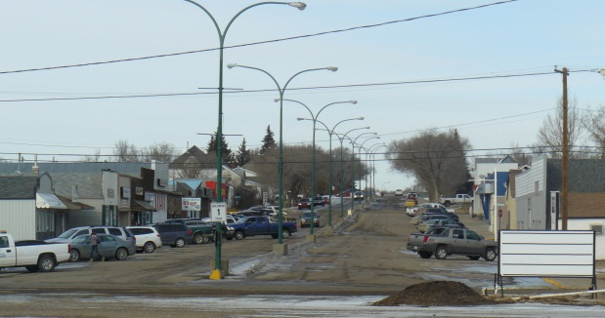
The Town will continue to consult with individuals, business owners and organizations in Macklin to identify initiatives that would encourage businesses and enterprises to locate in the Town Centre.

The Town Centre will be prioritized as a location for retail activity, professional services, government functions and cultural activities within Macklin to improve “downtown” options and experiences.

Macklin shall collaborate with business owners and organizations to pursue a Town Centre revitalization initiative. Private, Municipal and Provincial funding support shall be explored.

Community facilities around and in the Town Centre are supported. These facilities shall complement the commercial uses and serve residential development in the area.

Mixed-Use residential/commercial infill in the Town Centre shall be carried out so as to avoid or minimize potential land use conflicts with adjacent commercial development.

Any expansion of the Town Centre will be based on maintaining a continuous retail commercial area with regard to existing and adjoining land uses. Rezoning of commercial areas to residential will not be supported by the Town other than for higher density residential development.

Highway Commercial

Highway commercial services readily accessible to existing transportation infrastructure, at highly visible locations, shall provide vehicle and travel-related goods and services that do not significantly detract from the services provided in the Town of Macklin.

A wide variety of lot sizes will be provided to ensure the availability of land for a broad range of commercial activities. Commercial areas shall be provisioned with adequate infrastructure that can accommodate these developments in a timely, economical and environmentally sustainable manner.

The Plan encourages a variety of highway commercial development that is well planned for occupancy by highway commercial uses which serve the regional economy.

Improving Macklin’s aesthetic appeal from the highway entryways is an important consideration, including appropriate signage advertising amenities available in the community, landscaping and lighting attributes to attract business and customers.

Highway commercial uses shall properly integrate with provincial highways through the use of service road systems or controlled access points approved by the Saskatchewan Ministry of Highways and Infrastructure.

Home Based Businesses

Home-based businesses may be accommodated provided that they are clearly secondary to the principal residential use of the dwelling unit, are compatible with and do not change the character of the surrounding residential area and are not of a size, scale or use that would affect the viability of established commercial areas.

Home-based occupations or businesses shall be encouraged in the Town as valuable contributors to the District economy. The Zoning Bylaw shall specify development standards for home-based businesses.

IMPLEMENTATION
The Zoning Bylaw shall include the following commercial zoning districts:
C1 – Town Centre Commercial District | The purpose of the Town Centre Commercial District (C1) is to continue to encourage a “downtown” experience by providing pedestrian orientated commercial activities and services.
C2 – Highway Commercial District | The purpose of the Highway Commercial District (C2) is to facilitate a wide range of commercial and related activities located along the Provincial Highways requiring high visibility.

3.5 INDUSTRIAL DEVELOPMENT
The Town serves the agricultural and oil-Sector economies with a variety of support services, light industrial activities and welcomes future development initiatives.

Objectives
- To expand and build upon Macklin’s experience with industrial and agricultural and oil resource based activity.
- To cooperate with the North West Resource Corridor Planning District, senior levels of government and business organizations to promote and develop industrial and related service activities in Macklin.
- To identify areas for future industrial development and ensure there is sufficient industrial land available for primary, secondary and service industries in appropriate locations. .
- To accommodate future industrial development with a planned industrial park to provide a sufficient supply and variety of parcel sizes and servicing levels to attract a diverse range of industry.
- To recognize and market the strategic opportunities for development that the highway connections provide in Macklin.

Policies

The Town shall promote Macklin’s locational advantage when pursuing Industrial expansion in areas of agriculturally related activities, light industrial manufacturing, material transportation, and heavy equipment and support service activities.

Industrial areas shall be provisioned with adequate infrastructure that can accommodate these developments in a timely, economical and environmentally sustainable manner. The Town will encourage various industrial lot sizes and may provide varied servicing levels, including fully serviced (water, storm water, sewage) and lightly serviced parcels (water).

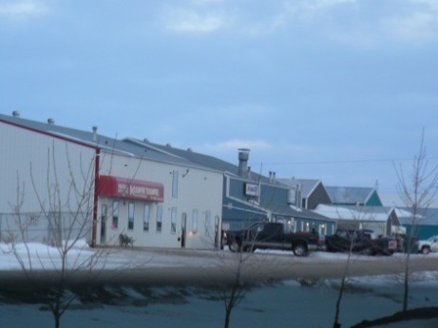
Industrial development shall be directed to lands readily accessible to existing transportation infrastructure to provide for efficient transportation and shipping operations. Industrial and associated commercial development shall be encouraged to cluster into nodes along established and future transportation interchanges.

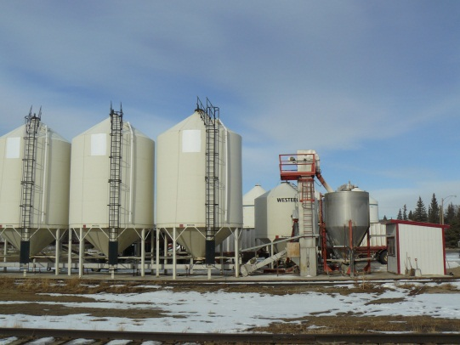
Industrial developments shall be situated in areas that have compatible land uses. Separation between incompatible uses is encouraged and landscaping and buffering shall be completed to reduce safety risks.

The designation of additional land for industrial use shall take into consideration the following criteria:
- the site shall have direct and approved access to a major public road system;
- the development will not generate additional traffic on residential streets;
- the development shall be not have adverse impacts on the natural environment, including groundwater resources; and,
- the development shall not detract from the visual attractiveness of the area.

Expansion of industrial areas shall comply with the policies in this Bylaw and in accordance with the Future Land Use Map for the Town of Macklin in Appendix A.

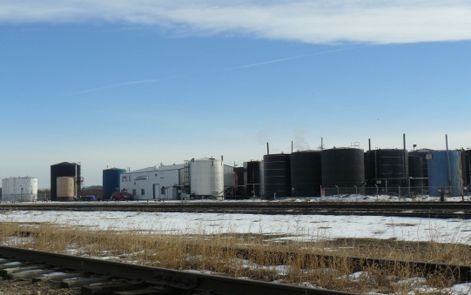
Care shall be taken in the siting of industrial uses that normally create very significant land use conflicts with regard to noise, vibration, smoke, dust, odor or potential environmental contamination. Such uses shall be encouraged to find a location that maximizes separation from residential areas and shall be visually screened or otherwise buffered to protect adjacent land uses.

Development proposals should be guided by Comprehensive Development Reviews and should indicate:
- future major roads;
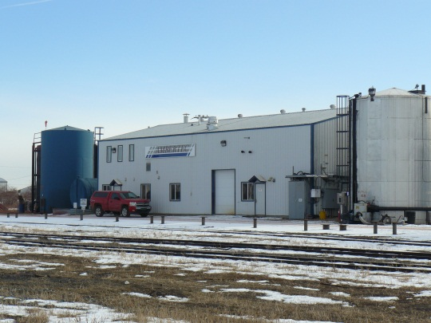
- drainage systems and improvements;
- major open space (including unique physical) areas;
- cultural and archaeological significant areas;
- areas requiring protection through buffering or other means;
- major hazards such as flooding, areas of high water table, and slope lands; and,
- phasing of development and future development of or expansion into adjacent land.

Industrial uses which are likely to be unsightly due to the nature of the industrial operations, exterior storage, or type of building or structures, should generally be discouraged from locating along the highway approaches and entrance roadways into Macklin. If such uses are proposed in these areas, special landscape buffer or other mitigation measures should be taken to screen these industrial uses from view.

Use-specific industries that exhibit a potential level of hazard or environmental impact which can only be mitigated through special separation shall be located according to the separation distances outlined by the appropriate Provincial agencies. Industries considered hazardous due to the transport, handling, bulk storage or use of hazardous materials shall be discouraged.
IMPLEMENTATION
Implementation to guide the future development of industrial activity will be guided by this Plan and the Zoning Bylaw shall include the following industrial zoning district:
IND – General Industrial District | The purpose of the General Industrial District (IND) is to provide areas for Industrial activities which have moderate potential for conflict with adjacent land uses and are partially dependent on exposure to high traffic areas.

3.6 TRANSPORTATION NETWORKS
Macklin is well-located along the highway corridors #31 and #14. Both highways are used regularly by travelers and industry. The CPR rail line runs through the Town and is a corridor for the Pleasant Valley and Saskatoon line.
A priority for the Town is to ensure a variety of transportation networks are available for pedestrians, cyclists and vehicles and that they are safe. There are opportunities for development along Highway #14.

Objectives
- To establish safe, efficient and convenient transportation facilities and service for all users.
- To provide a system of arterial, collector and local roads to accommodate anticipated traffic movements within the Town and provide an effective linkage to the provincial highway system.
- To ensure that road design permits safe and convenient vehicle, pedestrian and bicycle circulation.
- To maintain an adequate system of access and internal roads to serve the existing and future needs of the Town.
- To maximize the full benefit of the highway corridors going through the Town.

General Policies

Developments will ensure safe access and egress from adjacent roadways without disrupting their transportation function by locating on service roads adjacent to highways, on municipal streets, roads or at existing intersections.

Appearance standards that improve the visual appearance when entering Macklin may include landscaping, signage, or screening shall apply to lands near these entryways. Safety measures and controls may be added to areas where there is increased traffic. This will assist in reduce vehicle speeds through the Community.

Ongoing consultation with the Ministry of Highways and Infrastructure shall occur with regards to Highways #14 and #31. The Town will endeavor to coordinate the planning, construction, or alteration and any plans for future interchanges/intersections to address access requirements and to minimize any negative effects to Town residents and businesses. Signed truck routes shall continue to be monitored in order to minimize intrusion into residential areas.

All transportation and infrastructure projects shall be consistent with provincial transportation plans.

Street classification of local, arterial and collector streets should be established in order to promote orderly and efficient street systems. Control of access points and provision of service roads may be required in some instances.

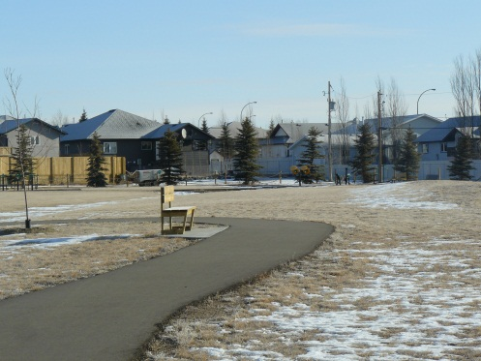
Roadway and pedestrian linkages between the Town Centre and peripheral areas will be established or identified to ensure multiple modes of movement including pedestrian, bicycles and vehicles, are provided with safe and efficient circulation. This may include exploration of a feasibility study for a pedestrian bridge or underpass across Highway #31 to the Communiplex.

The Town shall encourage public transportation modes including taxis, buses, commuter trains and car pool lanes that support fewer vehicles on the roads.

New roads will be planned and constructed with regard to land use and provision of suitable access. Property for road right-of-ways will be acquired through dedication or an agreement for purchase at the time of development or redevelopment of property. Rights-of-way of sufficient width will be provided to accommodate alternate forms of transportation to the automobile.

New subdivisions may be required to enter into a subdivision servicing agreement and all roads and sidewalk construction must meet municipal requirements. Any future subdivision shall provide for the general alignment of road networks identified in any adopted concept plan.

Streets, Roadways and Access

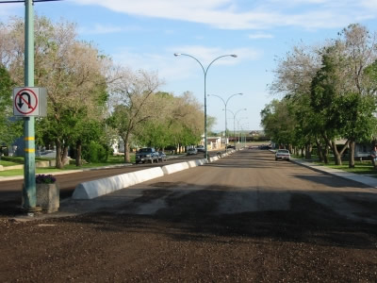
The Town shall provide residents with safe and improved roadways within the Community. Funding methods shall be explored.

The Junction at North Park is highly utilized. The Town shall explore traffic measure such as electronic lights in order to ensure safety of the community and travelers passing through.

Developments will ensure safe access and egress from adjacent roadways without disrupting their transportation function by locating: on service roads adjacent to highways, on municipal streets, roads or at existing intersections.

Appearance standards that improve the visual appearance when entering Macklin may include landscaping, signage, or screening shall apply to lands near these entryways. These areas shall be connected by pathways to the community.

Protection or mitigation for loss of existing trees and planting of new trees will be required in a safe and visually appealing manner along streets, roadways and in open spaces associated with new development.

Railway Policies

The municipality, through this Plan, shall provide for efficient and effective land use and transportation planning. This includes consultation with neighbouring property owners, including railways, in order to reduce the potential for future land use conflicts and provide adequate protection for rail infrastructure. The primary situations include:

new land development or redevelopment in proximity to existing rail operations,

new or significantly expanded rail facilities in proximity to existing residential uses; and,

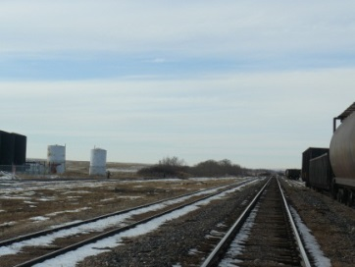
road and rail crossing issues.

Consultation with the Railways shall be required when a potential development is proposed for a:
- development or redevelopment proposals in proximity to rail facilities or for proposals for rail-serviced industrial parks;
- road and utility Infrastructure works which may affect a rail facility;
- transportation plans that incorporate freight transportation issues; and
- all new, expanded or modified rail facilities.

The Town should consult with the Railways regarding proposed land development and infrastructure projects which may have impacts on existing drainage patterns. Similarly, the Railways may consult with the Town where facility expansions or changes may impact drainage patterns to adjacent uses

A minimum 30 metre (98 ft) setback from the railway right-of-way property line to the building face shall be required for any new residential or commercial development. Setbacks from industrial development shall be determined through consultation with the Railways. Amendment Bylaw No. 05-2016.

Noise and vibration levels near roadways and rail lines shall be a factor in the evaluation of proposals throughout the development review process. Noise and vibration assessments may be required for new development within 300 metres (984 ft) from the rail line in order to prescribe mitigation measures and to determine the viability of foundation structures. Amendment Bylaw No. 05-2016.

All costs associated with preparing the noise and vibration assessment and implementing the approved mitigation measures shall be borne by the affected developers. Amendment Bylaw No. 05-2016.

3.7 INFRASTRUCTURE: ASSET MANAGEMENT PLANNING
The Town of Macklin is able to provide high quality infrastructure including water, waste management and recycling, phone, cable and internet, power and other utilities. All of these services are important to the residents and businesses with the hope that these services are sustainable for the long term.
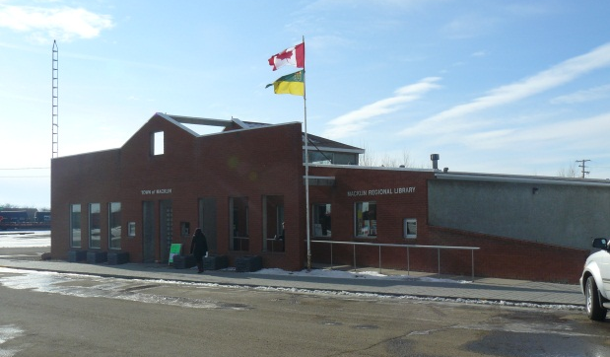
The Town is committed to providing these services and would like to expand their capacities to allow for growth. The Town shall explore expansion opportunities with neighbouring municipalities to include waste management and transfer station with West Yellowhead Waste Resource Authority (WYWRA), water delivery, new IT technologies and energy efficient structures.

Objectives
- To take a proactive approach in infrastructure planning in order to direct investment and conserve financial resources.
- To maintain, preserve and enhance the infrastructure system, by encouraging a continuous process of upgrading and project prioritizing.
- To provide effective municipal services that can be supplied economically and safely to a standard equal for all residents of Macklin that meets the demands of a growing population.
- To extend municipal services in an efficient manner by encouraging infill development on existing serviced lands.

Infrastructure asset Management Plan Policies

The Town shall develop and maintain an Infrastructure Asset Management Plan to ensure affordability in the long-term to:
    - provide baseline information to measure performance;
    - improve efficiency and effectiveness;
    - rank relevant and up- to-date inventory;
    - analyze the system‘s condition and capacity; and
    - budget service life for long term replacement.

The progress of the Plan shall be monitored as it is a working document for the short and long term and as such has a schedule, budget and deliverables.

The current and projected Infrastructure Capacities for the Town of Macklin are attached as Appendix “C.”

Strategies and standards for the orderly, efficient and economical extension of water distribution systems, streets, waste management facilities and storm water management requirements must be adopted and implemented the Infrastructure Asset Management Plan policies.

The Town shall ensure that capital works/infrastructure assets maintain or exceed current standards and shall incorporate servicing standards into all infrastructure upgrading and extensions.

Public works and Service Policies

The use of existing municipal infrastructure should be optimized wherever feasible before consideration is given to developing new infrastructure and public service facilities.

Infrastructure and public service facilities shall be provided in a coordinated, efficient and cost-effective manner to accommodate projected needs by integrating servicing and land use considerations at all stages of the planning process.

Preference will be given to reinforce existing services, however, when municipal services are expanded to new development areas the cost of extending these services shall be borne by the development itself and be located in areas with compatible land use. Front end costs of expanding municipal services shall be recovered through off-site development levies.

Adjacent lands shall be setback from existing public works facilities and any planned future expansion to minimize the encroachment of incompatible lands near landfills, waste management facilities, airstrips, transportation corridors, rail yards, and industrial activities.

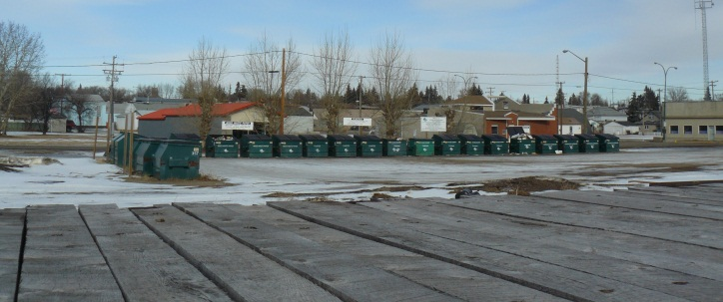
Planning for water provision and waste management services shall ensure that current systems are provided in a manner that can be sustained by the water resources, are financially viable and compliant with all regulatory requirements and protect public health and the natural environment.

The Town shall ensure adequate storm drainage of all areas of the community by preserving natural holding areas or by other means as may be engineered and constructed.

All developments shall be serviced in agreement with the Future Land Use Map or any future Area Concept Plans. The adequacy of municipal services will be monitored and upgrading or expansion of these systems shall equitably meet the needs of residents and other customers.

Future subdivisions and development shall be logical, reasonable, and cost effective and will be limited to areas that can be efficiently provided with municipal services that will be serviceable at an acceptable cost to the Town.

The building of facilities and activities that encourage or enhance energy efficiency, waste reduction, re-use or recycling of wastes shall be accommodated and programs to reduce the volume of solid waste, such as "reduce, reuse, recycle", shall be supported.

The Town shall pursue a comprehensive Waste Management Plan to explore and continue the regionalization of solid waste management and waste disposal alternatives. Emphasis on solid waste management shall include waste minimization principles with emphasis on organic waste diversion.

The Town of Macklin shall continue to participate with the West Yellowhead Waste Resource Authority (WYWRA) and adjacent Rural Municipalities in providing and enhancing effective waste management and environmental protection. Support will be given to the proper management and safe disposal of domestic sewage, solid and industrial wastes.

The Town shall consider opportunities for the incorporation of regional energy production and public works.

For the subdivision of private land, the proponent will generally be responsible for all costs associated with providing municipal utilities services negotiated through a servicing agreement.

3.8 COMMUNITY SERVICE AND RECREATIONAL LANDS
Macklin has a wealth of public amenities, educational institutions, local clubs and organizations, religious facilities, sports, recreation and cultural facilities. The Town has a vibrant Communiplex that includes a skating rink, curling rink, banquet hall and meeting rooms. Macklin recently added a new swimming pool named the Macklin Alliance Pipeline Aquatic Centre. Other services include: the Macklin School, Great Plains College, golf course, Regional Park, homecare facility, adult equipment park/playground.
One significant characteristic that stands out for the Town of Macklin is the strong sense of community and volunteer effort. Everyone comes together to help out when needed to support sports and recreation. The community is welcoming to newcomers and they want to share the pride they have in their community and the services it can offer.

Objectives
- To capitalize on existing community facilities in order to attract residents, commerce and other opportunities.
- To support education and health services to meet the needs of the Town and the District.
- To advocate for air ambulance to increase health, safety and emergency needs of the community and area.
- To provide for recreational amenities, institutional, community services and cultural facilities that are accessible and available for all ages and lifestyles.
- To explore the need for a greater variety of multi-function indoor recreational facilities and support local interest in existing year-round outdoor activities.
- To provide for appropriate sport, recreational, and cultural facilities.
- To promote cooperation and collaboration of recreation and social organizations and programming.
- To encourage corporate investment in the Community of Macklin’s recreational assets.
- To provide recreation and preserve open space areas with aesthetic value to meet the community needs and contribute to the community’s appearance.
- To work with the Macklin Regional Park Authority to explore the opportunities the Regional Park has for the residents of the Town and District.

Community facilities and institutional Policies

The Town shall support the development and joint-use of institutional, health, recreational, spiritual and cultural facilities for the benefit of the Town and surrounding municipalities in the District.

Community Service lands include institutional, public services, recreational, health, cultural or educational uses. The development of institutional, recreation or cultural facilities shall be encouraged to locate where services can be shared or have a joint-use and shall assess the impact future adjacent land uses may have on their activity.

The Town shall explore alternative energy options for the public utility of community amenities and facilities.

Community Service, institutional uses and parks may be located in any land use designation in the Plan area, with each rezoning proposal evaluated based on individual merit and their compatibility with surrounding land uses. Within the Plan area, community service, institutions and parks may be located in any designation where rezoning is based on individual merit and compatibility with surrounding land uses.

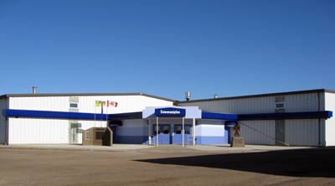
The Town will ensure that adequate land and buildings are made available to a full range of institutional, public and community services. When possible, social and cultural institutions will be encouraged to locate in or close to the Town Centre or near the Communiplex in order to promote accessibility and support revitalization efforts.

The Town shall enhance the physical, social, and cultural well-being of residents through support for the arts, culture, recreation, library, fire, police, education, social programs and health services to meet present and future needs.

Proposed community service developments will be evaluated based on their location, site layout and proper vehicular access, the compatibility of land use, and the provision of adequate municipal services.

Neighbourhood-oriented institutional uses such as schools, churches, day care facilities may locate within the neighbourhood area they serve. The Zoning Bylaw provides the provisions for community service uses including site regulations.

Most of the recreational facilities and programs are provided through the Town and various volunteer groups. The creation of a Parks and Recreation Board and Director is recommended. Expanding and maintaining these recreational amenities should be a priority in order to enhance the lifestyle options for the residents of Macklin and the District.

The Town of Macklin will continue to work in partnership with other jurisdictions, the adjacent Rural Municipalities and other agencies as a means of providing, sharing and funding community services effectively and efficiently.

Programs that are accessible to all will be encouraged. The Town, with other organizations will explore opportunities to provide some free programming and events for residents and visitors.

The Town of Macklin will ensure publicly funded developments are safe, accessible to all and are conducive to social interaction by encouraging barrier free access design and other considerations specific to a particular development.

The Town shall work with youth in the community to locate and create a youth centre with a variety of programming and activities for youth.

Recreational, Trails and Park Policies

A balance of indoor and outdoor experiences shall be provided to ensure recreational facilities receive optimum usage and can be used by all residents in the District for year-round recreational pursuits.

The Town shall support access to unoccupied Crown lands for recreation, tourism, hunting and fishing.

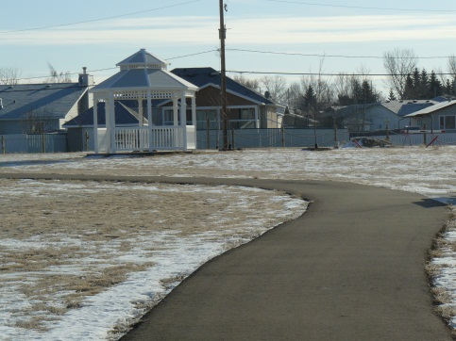
Future recreational uses in Macklin shall include the development of structures, buildings and landscaped areas which, without limiting innovation and marketing attributes, are compatible with adjacent uses and ensure a high level of visual and aesthetic quality.

The Town will work with public organizations and private sector developers to encourage and facilitate the development of new, or the upgrading of existing recreational and community facilities and programming. New developments shall have minimal impacts on existing or planned recreational and tourism areas.

A network of pedestrian and bicycle trails between parks, recreational and institutional uses within the community shall be identified. The Town shall strive to provide and maintain year-round, safe, well-lit and convenient trails for pedestrians, scooters and cyclists.

In new residential subdivisions, the provision and development of buffer and pathways will be encouraged to separate incompatible land uses, and, if possible, to keep important natural and nature-like areas generally intact.

Park space will be provided as required to meet public needs. Equitable distribution of built and natural settings for recreation, including facilities, parklands, open space areas, and trails shall be encouraged.

Natural areas and park space should be maintained, to the greatest extent possible, as an environmental and educational resource to facilitate understanding and appreciation of the natural environment.

Green space is identified on the Future Land Use Map found in Appendix “A”, green (or open) space is considered to be passive and structured leisure and recreational areas that enhance the aesthetic quality and conserve the environment of the community. The Town shall ensure these spaces are protected into the future. Amendment Bylaw No. 05-2016.

The Town shall ensure green space is integrated as part of new developments especially in residential, core commercial, and community service areas. Green spaces will enhance the aesthetics of these areas and provide residents recreational opportunities. Amendment Bylaw No. 05-2016.

The upkeep of trees and planted boulevards shall be encouraged within the Town to highlight and provide attractive natural features.

Private sector development and operation of parks and recreation facilities will be encouraged. Designation of lands for parks and recreational purposes indicates suitability of such lands for the purpose and offers opportunity for private/public partnerships or ownership.

Publicly or privately owned recreation and open space may consist of buffer strips, walkways and utility rights-of-way.

Municipal and Environmental Reserve Amendment Bylaw No. 05-2016

Subdivision applicants will be required to dedicate the full amount of Municipal Reserve owing in the forms provided for in The Planning and Development Act, 2007.

Subdivision applicants will be required to dedicate, as Environmental Reserve, all lands in an area to be subdivided that can be defined as Environmental Reserve in accordance with the provisions of The Planning and Development Act, 2007.

Land provided as an Environmental Reserve becomes the property of the municipality. An applicant applying to subdivide land may be required to provide any amount of land in any location that the approving authority considers necessary, if the land consists of:

A ravine. coulee, swamp, natural drainage or creek bed;
- Wildlife habitat areas that:
  - Are environmentally sensitive; or
  - Contain historical features or significant natural features.

Where development is proposed adjacent to a watercourse, the Town will request the subdivision approving authority to dedicate Municipal or Environmental Reserve as appropriate to protect sensitive areas and ensure continued public access to these areas.

Dedication of municipal reserve is required for subdivision; the municipality may accept cash-in-lieu of dedication, deferral or a combination of dedication and cash-in-lieu unless there is an identified need for recreational land in the vicinity of the development. Where cash-in-lieu is taken, the money may be used to purchase municipal reserves, particularly where the land can also be used for storm water management or for the expansion and development of public reserve and environmental reserve as needed in other areas.
IMPLEMENTATION
The Zoning Bylaw shall include community, institutional services recreational land uses and activities in one Zoning District:
CS – Community Service District | The purpose of the Community Service District (CS) is to provide areas for a wide range of community service related activities including social, recreational, institutional, parks and public service.

3.9 HERITAGE AND CULTURAL RESOURCES
In 1909, Macklin was incorporated as a village and later became a town in 1912. Macklin is named after a news reporter named Harry Macklin who followed the rail construction in the area. Many of the streets in Macklin are named after journalists that were famous at the time of subdivision.
Another part of Macklin’s history is relived with the Bunnock Tournament that is held every year. The game of bunnock was developed by Russian Germans and later was introduced to the Macklin area. This annual event draws hundreds of people from around the province and beyond.
The Macklin Museum showcases early settler memorabilia and artifacts. Other heritage and cultural resources can be seen on the Town’s Main Street which includes some historic buildings and structures. Macklin is proud of their heritage and wants to protect these historic and cultural resources within the Town.

Objectives
- To provide for the protection and conservation of cultural and heritage resources.
- To identify and conserve to the extent feasible, the best elements of the Town’s cultural heritage, architectural character, buildings, sites and other historical and cultural features.
- To prioritize projects which promote local interest in Macklin’s culture, heritage attributes and identity.
- To encourage partnerships among community interest groups and businesses to promote the Town’s cultural assets throughout the region.

Policies

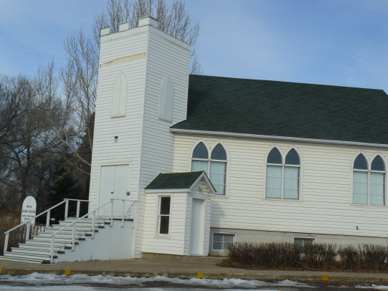
The Town will cooperate with community stakeholders to identify and continually assess the significance of historic, cultural sites and special areas within Macklin.

At the request of owners and in accordance with The Heritage Properties Act, significant historic sites and architectural features shall be designated as heritage properties and suitably recognized.

The Town will demonstrate the appropriate use and treatment of properties designated through The Heritage Property Act.

The Town will utilize the Standards and Guidelines for the Conservation of Historic Places in Canada to guide and inform conservation projects on historic places which are owned, regulated, funded, or guides by the municipality.

Existing and potential heritage resources should be protected from incompatible or potentially incompatible land uses, which may threaten their integrity or operation.

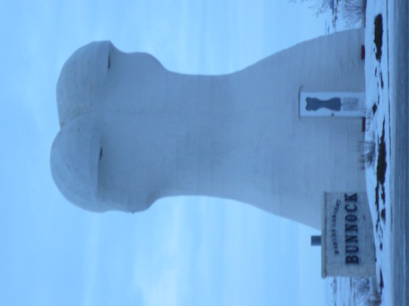
Opportunities for the reuse, rehabilitation, preservation or restoration of historic buildings shall be encouraged by the District.

The Town shall promote the Macklin Museum and the Bunnock Tournament as primary community and regional cultural assets. The museum shall be encouraged to market on-site activities and programming that stimulates a regional tourism experience that commences in Macklin.

Agricultural and industrial heritage may be highlighted through the naming or sponsorship of public amenities and spaces. Recognition, through signage or place naming, shall be encouraged throughout Macklin to honour significant citizen and corporate contributions.
IMPLEMENTATION
Heritage and cultural resources and sites shall be exempted from site frontage area requirements and shall be a discretionary use in all zoning districts. It is important to respect the heritage and cultural assets within the Town and surrounding area. These play an integral role in educating residents and visitors about the history of the area.

3.10 ENVIRONMENTALLY SENSITIVE AREAS
The Town of Macklin is part of the Macklin Lake Regional Park. This area consists of a lake, camping and golf course. It is used for passive recreation and wildlife can be viewed here. It is important to the community that the lake, water flow and wildlife habitats are protected from contamination.

Objectives
- To acknowledge and protect natural, environmental features, and systems within the Town and in the adjacent Rural Municipality of Eye Hill.
- To restrict development activities that alter drainage patterns that would accelerate or promote damages arising in some areas.
- To extend the responsibility for sound environmental management to property owners and developers.

Policies

Natural areas and sensitive environmental areas shall be identified and protected where human activities may create potential to stress the environment.

Development shall not deplete or pollute groundwater resources within the Town. Permeable surfaces shall be maximized to reduce storm water runoff and recharge groundwater.

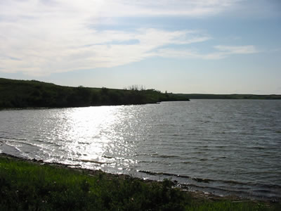
The Town shall consider the ecological value, integrity and management of wetlands, riparian areas, significant natural landscapes and regional features, and provincially designated lands.

Environmentally sensitive lands that may be identified in Macklin should be protected as environmental reserve in accordance with The Planning and Development Act, 2007, the Environmental Assessment Act, and the Environmental Management and Protection Act, 2002.

Before approval of new development, the Town shall consider the effects of the development on water quantity and that there is an established or proven supply of water capable of servicing the needs of a proposed development.

The Town of Macklin may undertake a review of a storm-water management and Drainage Management Plan for both existing development areas and future residential, commercial and industrial areas. New developments shall assess local water drainage patterns as part of initial concept designs and avoid developing in low-lying catchment areas and drainage courses.

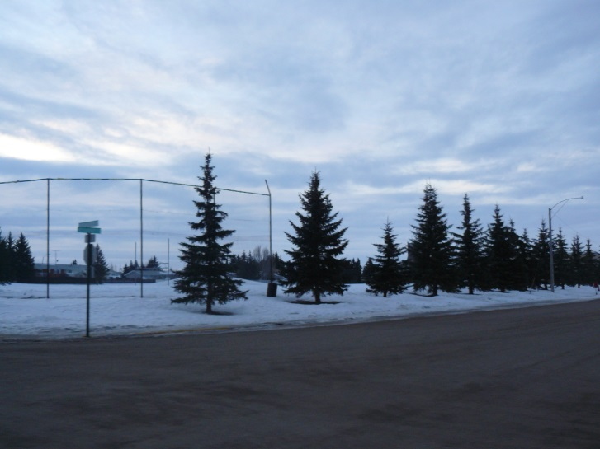
Buffer Strips should be maintained adjacent to watercourse and water bodies to allow for protection measures against erosion, sediment control and flood hazards. Wetlands shall be preserved for the benefit they serve as catchment basins for drainage.

Adequate surface water drainage will be required throughout the Town and on new development sites to avoid flooding, erosion and pollutions. Consideration shall be given to the ecological, wildlife habitat and drainage effects of development, including the upstream and downstream implications.

3.11 FUTURE URBAN DEVELOPMENT
The Town of Macklin has a large tract of land to the east which is undeveloped. This land is currently used for agricultural practices and is encouraged to be utilized for such until it is necessary to expand the Town.

oBJECTIVES
- To plan for the possibility of urban expansion with regards to infrastructure, future land use needs and other services.
- To ensure development occurs in a manageable and sustainable manner.
- To promote the continuation of urban agricultural activities on lands located within the Town boundaries.
- To promote the continuation of urban agricultural activities on lands located within the Town boundaries and provide for opportunities for growth, diversification and expansion of urban agriculture and value-added agribusiness development.

Policies

Future Urban Development areas are identified within the Town limits on the Zoning District Map as the Future Urban Development District. Amendment Bylaw No. 05-2016. These are areas where the future use of land or the timing of development is uncertain due to issues of servicing, transitional use, or market demand.

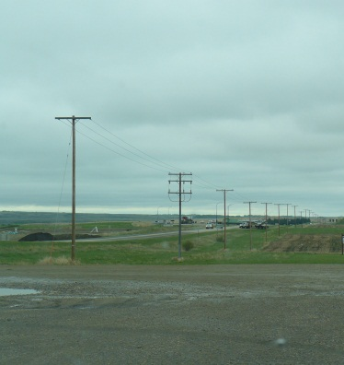
Development and land use patterns which are adjacent or in proximity to urban areas that may have negative effects on future urban design and densities that may hinder expansion will be discouraged, or mitigated. This does not apply to such effects that arise in the course of normal, non-intensive farm operations.

Future Urban Development Areas may include:
- lands which are capable of a full range of utilities, though for which no overall area concept plan has been approved for the general area; or,
- lands which are not readily capable of being serviced with a full range of utilities, and for which no concept plans have been approved.

Urban Agricultural Policies

Agricultural holdings within the Town’s boundary shall be encouraged to protect the natural and economic value of their soils by minimizing activities that cause soil degradation or loss. Topsoil should be retained, where possible to provide a rich basis for site planting and landscape development.

Land areas shall remain in large acreages in order to facilitate future land assembly and development proposals. The type of agricultural buildings and structures shall be located in a manner that agricultural uses may continue until required for urban types of development.

In order to facilitate an orderly and economic conversion, the zoning regulations on these lands should take into consideration the following criteria:
- lands presently in agriculture use shall be retained for such use in the interim period;
- agricultural activities will be of a type which will not create any unacceptable nuisance factors or hazard;
- the interim development of these lands shall be regulated in such a manner so as to facilitate an economic conversion to urban use; and,
- capital investment in buildings and structures shall be limited in order to minimize obstacles for future urban development.
IMPLEMENTATION
The intent of the FUD-Future Urban Development Zoning District is to allow for rural and agricultural uses to continue as transitional land uses. This zoning designation will be applied as the interim zoning to all “rural” land with Future Urban potential within the corporate boundaries of the Town of Macklin.
FUD – Future Urban Development District | The intent of the Future Urban Development (FUD) Zoning District is to allow for rural and agricultural uses to continue as transitional land uses. This zoning designation will be applied as the interim zoning to all “rural” land with Future Urban potential within the corporate boundaries of the Town of Macklin.

Section 4: ADMINISTRATIVE TOOLS
- ACTION PLANNING
Successful implementation of this Plan depends to a large degree on whether its policies can guide local development and action in a variety of contexts over the next twenty to twenty-five years. This Section contains policies to ensure that planning is sensitive to local conditions in specific locations of the Town, while at the same time advancing the Plan’s core principles and building on its broad objectives.
To achieve the goals set out in this Official Community Plan and the North West Resource Corridor District Plan, a clear plan of action or implementation strategy is required. Action Plans for the North West Resource Corridor Planning District have been included as an appendix to the District Plan. The Town of Macklin may choose to undertake action planning as part of this Official Community Plan. Each action item will relate to the policy statements included in the Plan and will require the action items to be prioritized. The actions items will be reviewed regularly to monitor progress and to determine if changes are required.
The Plan Guides Action
As a statutory document for guiding development and land use in the Town, the Plan gives direction to Council on their day-do-day decision making. The Plan’s land use policy areas illustrated in the Future Land Use Map in “Appendix A” provide geographic references for the municipality’s policies. If the Town is to move closer to the future envisioned by the Plan, the Plan must guide other related decisions of Council. The Planning and Development Act, 2007 requires that:
- Municipal bylaws and public works will conform to this Plan;
- The decisions and actions of Council and Municipal Administration, including public investment in services, service delivery and infrastructure, will be guided by this Plan; and,
- Implementation plans, strategies and guidelines, consistent with this Plan will be adopted, identifying priorities, detailed strategies, guidelines and actions, to advance the vision, goals and objectives of this Plan.
The Future is a Shared Responsibility
Communities are successful when all sectors co-operate with their time, effort and resources to enhance the quality of life in the greater community or district. The Town, together with the North West Resource Corridor Planning District can lead by example with engaged and informed residents to successfully guide the future, measured by the accomplishments made in environmental stewardship, economic development, community service provision, population growth, social planning, and the overall lifestyle available in the Town and District.

- IMPLEMENTATION AND MONITORING
Planning Tools
This Section outlines the variety of traditional tools the municipality has available to make things happen. The Planning and Development Act, 2007 provides the authority that governs plans of development, zoning bylaws, servicing agreement, development levies and review processes to ensure that the Plan is effective over the long term.
Definitions
The Town of Macklin’s Zoning Bylaw definitions shall apply to this Official Community Plan. Any amendments to the Zoning Bylaw definitions shall ensure they do not conflict with the intents of the North West Resource Corridor District Plan, to which this OCP relates. The Town may refer any proposed changes to the District Planning Commission for review.
Adoption of the Official Community Plan
Adoption of this Official Community Plan by the Town will give it the force of law. Once adopted, no development or land use change may be carried out within the area affected by the Official Community Plan that is inconsistent or at variance with the proposals or policies set out in the Official Community Plan and the North West Resource Corridor District Plan.
By setting out goals, objectives, and policies, the Official Community Plan will provide guidance for the Town in making decisions regarding land use, zoning, servicing extension and development in general. It will also provide the Town with the ability to provide input on future subdivision applications. These decisions must be made in conformity with the stated objectives and policies to ensure that the goals for the future development of the municipality will be achieved.
The application of the Official Community Plan policies is illustrated in the Future Land Use Map contained in “Appendix A.” This Map is intended to illustrate the locations of the major land use designations within the Town of Macklin. This “Map” should not be interpreted in isolation without consideration of the balance of the Official Community Plan. The Land use designations have been determined by a number of factors including existing patterns of land use, projected land needs, resource areas, natural attributes and man-made features.
The Official Community Plan will be implemented, in part; by the development-related decisions that will be made in the future; however, the two most important tools available for guiding the future development of the municipality are the Zoning Bylaw and the subdivision process, including associated agreements.
Adoption of the Municipal Zoning Bylaw
Following the adoption of the Official Community Plan, the Town of Macklin is required to enact a Zoning Bylaw which will set out specific regulations for land use and development:
- The Zoning Bylaw must generally conform to the Official Community Plan, and the District Plan and future land use and development shall be consistent with the goals and objectives of this Plan;
- Future development will avoid land use conflict and meet minimum standards to maintain the amenity of the municipality;
- Zoning Bylaws designate areas for certain types of development. Permitted and discretionary uses and development standards prescribed for each zone;
- Development will be consistent with the physical opportunities of the land and of reasonable engineering solutions;
- Undue demand shall not be placed on the municipality for services, such as roads, parking, water, sewers, waste disposal, and open space;
- The objectives and policies in the Official Community Plan, and the District Plan, provide guidance to Council when preparing the Zoning Bylaw or considering an amendment to the Zoning Bylaw.
The Zoning Bylaw will be used to implement the policies and achieve the objectives of this Plan by prescribing the uses of land, buildings or other improvements that will be allowed in the different zoning districts established in the municipality. In addition, the Zoning Bylaw regulates how these uses may be carried out and the standards that developments must meet.
The Zoning Bylaw provides the Town with actual control over land use and the types of development and uses allowed in each land use district. The associated supplementary requirements and development standards will be specified in the Zoning Bylaw respecting building setbacks, parking, loading, landscaping, signage, buffering and all other relevant standards prescribed by the Town.
To ensure that these regulations work to help achieve the stated goals and objectives, the Bylaw itself must be consistent with the policies and the intent of this Plan. In considering a Zoning Bylaw or an amendment, the municipality should refer to the policies contained in the Official Community Plan, District Plan and the “Future Land Use Map” (Appendix A), to ensure that the development objectives of the municipality are met.
Adoption of the North West Resource Corridor District Plan
The North West Resource Corridor Planning District has adopted the North West Resource Corridor District Plan as per The Planning and Development Act, 2007. The District Plan will be utilized in conjunction with the Town of Macklin Official Community Plan to guide land use development decisions at the local and district level over the next 25+ years.
In support of the North West Resource Corridor District Plan, the municipalities are committed to pursuing voluntary District Planning Commission status to oversee and implement the District Plan. The North West Resource Corridor District Planning Commission Agreement sets out all provisions with respect to the District Planning Commission, including boundaries of the District, amendments, and others as per The Planning and Development Act, 2007.
Contract Zoning
For purposes of accommodating a rezoning for unique development situations, Council may consider entering into rezoning agreements, pursuant to provisions of The Planning and Development Act, 2007. The person applying for a rezoning agreement to have an area of land rezoned to permit the carrying out of a specified proposal, the council may enter into an agreement with the person setting out:
    - A description of the proposal;
    - Reasonable terms and conditions with respect to:
- The uses of the land and buildings or the forms of development; and
- The site layout and external design, including parking areas, landscaping and entry and exit ways, but not including the colour, texture or type of materials and architectural detail;
    - Time limits within which any part of the described proposal or terms and conditions imposed pursuant to clause (b) must be carried out.
    - A condition that, on the rezoning of the land, none of the land or buildings shall be development or used except in accordance with the proposal, terms and conditions and time limits prescribed in the agreement.
Section 69 of The Planning and Development Act, 2007 contains the provisions on entering into a rezoning agreement. The following are additional guidelines:
- The rezoning to permit the development will not unduly conflict with adjacent land uses that are legally permitted uses within the proposed or adjacent zoning district;
- The rezoning will be used to allow a specific use or range of uses contained within the zoning district to which the land is being rezoned;
- The development or redevelopment of the site for the specific use will be of benefit to the immediate area and the municipality as a whole;
- The use of these zoning tools does not undermine the intent of the Plan or any affected legislation such as The Condominium Act or Environment or Health regulations.
Concept Plans
Concept plans represent design layout concepts prepared at the request of the Municipal Council to provide direction for how new developments:
- Ensure the efficient provision of infrastructure services;
- Demonstrate how site development will be organized to ensure compatibility with adjoining land uses and transportation systems; and,
- Provide design features for special purposes such as landscaping, buffers, open space, pedestrian and vehicular access.
In accordance with Section 44 of The Planning and Development Act, 2007, a Council may, as part of the Official Community Plan, adopt a concept plan for the purpose of providing a framework for subsequent subdivision and development of an area of land. The Council shall ensure that any concept plan is consistent with its Official Community Plan, and any part of a concept plan that is inconsistent with the Official Community Plan has no effect insofar as it is inconsistent.

Comprehensive Development Reviews
A Comprehensive Development Review may be completed by any person proposing to rezone land for multi-parcel country residential, commercial, industrial, or Intensive Livestock Operation purposes. The purpose of this Comprehensive Review is to identify and address social, environmental, health and economic issues appropriately and to encourage the development of high quality residential, commercial, and industrial developments. This review proposes to address the following topics:
- Proposed land use(s) for various parts of the area;
- The effect on adjacent land uses and integration of the natural landscape regarding the planning and design of the area;
- The location of, and access to, major transportation routes and utility corridors;
- The provision of services respecting the planning for future infrastructure within the municipality;
- Sustainable development and environmental management practices regarding surface and groundwater resources, storm water management, flooding and protection of significant natural areas;
- Appropriate information specific to the particular land use (residential, commercial or industrial); and,
- Proponents may be required to undertake and submit special studies as part of the approval process for certain types of development proposals. Engineering or other professional studies may be required including traffic studies to determine impacts upon the municipality’s road and highway system, assessments of lands affected by flooding or slope hazards, endangered species, heritage resources, potential for ground and surface water pollution, and general risk to health and the environment.
Performance Bonds, Insurance and Registering interest
Council may require a developer to post and maintain a performance bond to ensure developer performance and to protect the public interest.
Council may require developers to provide and maintain liability insurance to protect the municipality, developer and public.
Council may require that development servicing agreements and other documents be registered as an interest against the title to the affected lands, to protect municipal and public interests. Amendment Bylaw No. XX-2016.
Development Levies and Agreements
Council may adopt a Development Levy Bylaw as specified in Section 169 to 170 of The Planning and Development Act, 2007, for the purposes of recovering all or a part of the municipalities capital costs of providing, altering, expanding or upgrading the following services and facilities associated, directly or indirectly, with a proposed development:
- Sewage, water or drainage works
- Roadways and related infrastructure
- Parks
- Recreational facilities.
Before adopting a Development Levy Bylaw, Council will undertake studies necessary to define the benefiting areas and the unit costs associated with required capital upgrading of off-site services.
Council may request a developer to enter into a development agreement to ensure development conformity with the Official Community Plan and this Bylaw, pursuant to Section 171 to 176 inclusive, The Planning and Development Act, 2007. The development agreement will specify the owed levies based on the proposed development and the Development Levy Bylaw. Amendment Bylaw No. XX-2016.
Service Agreements
Where a development proposal involves subdivision, Council may require the subdivision applicant/developer to enter into a servicing agreement to provide services and facilities that directly or indirectly serve the subdivision to the standard required by Council, pursuant to Section 172 to 176 inclusive, The Planning and Development Act, 2007. The servicing agreement may provide for:
- The undertaking and installation of storm sewers, sanitary sewers, drains, water mains and laterals, hydrants, sidewalks, boulevards, curbs, gutters, street lights, graded, graveled or paved streets and lanes, connections to existing services, area grading and levelling of land, street name plates, connecting and boundary streets, landscaping of parks and boulevards, public recreation facilities, or other works that Council may require, including both on-site and off-site servicing;
- The payment of levies and charges, in whole or in part, for the capital cost of providing, altering, expanding or upgrading sewage, water, drainage and other utility services, public highway facilities or park and recreation space and facilities located within or outside the proposed subdivision and that directly or indirectly serve the proposed subdivision;
- Time limits for the completion of any work or the payment of any fees;
- Provision for cost sharing between the Town and developer; and,
- Any assurances as to performance that Council may consider necessary.
The servicing agreement becomes a condition of approval of a subdivision by the approving authority. The requirements, conditions, and fees may vary depending upon service needs. Amendment Bylaw No. XX-2016.
Subdivision Process
The Director of Community Planning for the Ministry of Government Relations is currently the approving authority for subdivisions in the Town of Macklin and the North West Resource Corridor Planning District. The municipality has input into the subdivision procedure:
- The municipality provides comments on all subdivision applications within the municipality;
- As per the North West Resource Corridor District Planning Commission Agreement, the Commission may provide recommendations and comments to the municipality on any major subdivision application;
- The municipality has an impact on the subdivision process through the Zoning Bylaw, since no subdivision can be approved that does not conform to the Zoning Bylaw. In the Zoning Bylaw, the municipality can establish the minimum area, width, or depth of lots, and other spatial and land use standards. Zoning is intended to implement the municipality and District’s development policies, and to ensure that subdivisions contribute to achieve the long term goals of the municipality;
- In order for the subdivision to be completed in a timely manner, it is advisable to consult with the planning staff of the municipality before submitting a subdivision proposal to Government Relations.
Monitoring Performance
The Official Community Plan is a document intended to guide decision making over the long term and is not a static document that commits the Town to an inflexible development policy. As new issues and concerns arise, or old ones change, the Plan shall be revised to meet these changes. The "Plan" shall be reviewed after five years and before ten years from the date of its adoption by Council to evaluate the stated goals, objectives and policies as to their relevancies.
The Official Community Plan must be kept up to date to ensure that the document will deal with the real development issues facing the Town and the greater community. New implementation initiatives will be needed and priorities will require adjustment in response to the varied and changing conditions in the municipality.
Amendment
On occasion, land uses or developments may be proposed that do not conform to the Official Community Plan. The Plan can be amended in accordance with The Planning and Development Act, 2007, to allow the new development to proceed, however, before any amendment is made, the impact of the proposed change on the rest of the Plan and the future development of the Town shall be examined. Any changes to the Plan or the Zoning Bylaw shall be in the interest of the future development of the community as a whole. Through periodical review and amendment the Plan should serve as an effective guide for Council to make decisions on the future development of the municipality.

Appendices
Appendix A: Future Land Use Map
Appendix “B”: Reference Maps
- Community, Park and Recreational Amenities
- Health, Safety and Emergency Services
- Heritage Sites
- Flood Prone Areas
- Transportation Hierarchy
Appendix “C” Infrastructure Capacities

APPENDIX “A” – TOWN OF MACKLIN FUTURE LAND USE MAP
Amendment Bylaw No. XX-2016
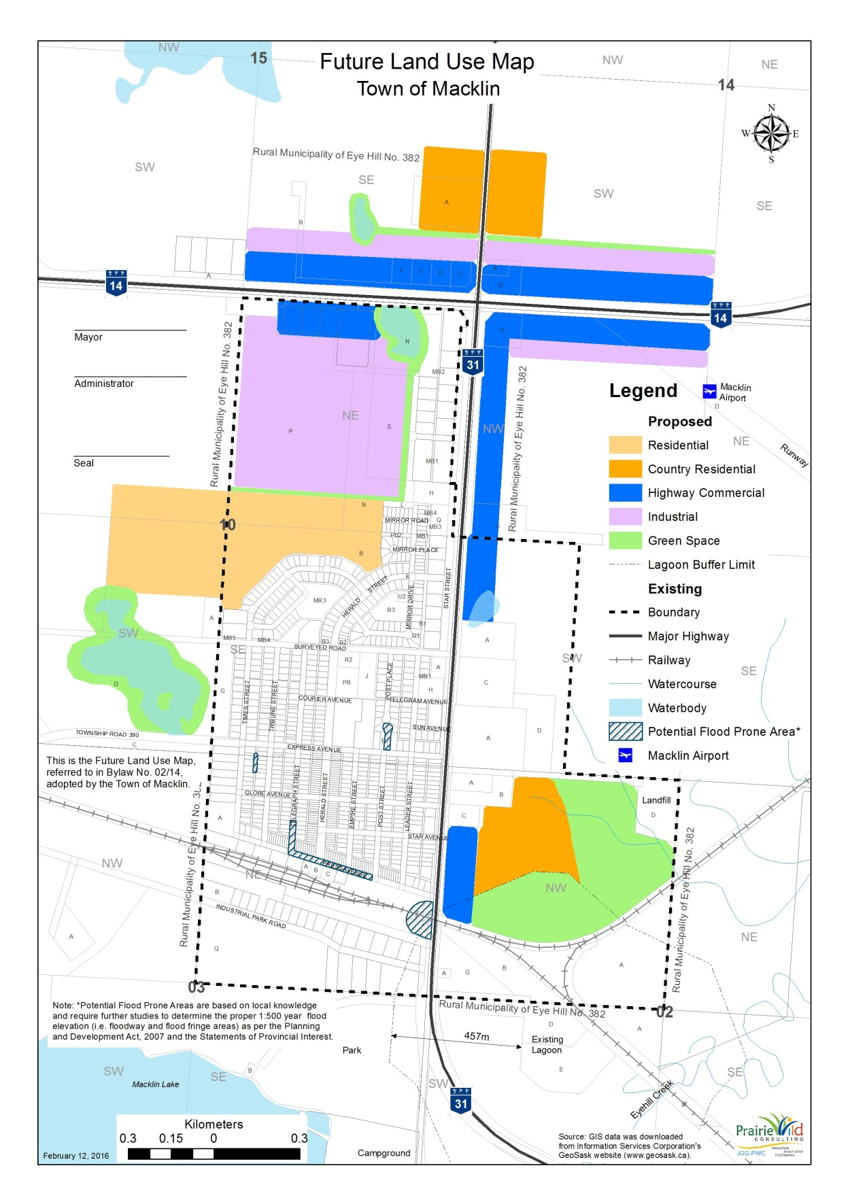
APPENDIX “B” – REFERENCE MAPS
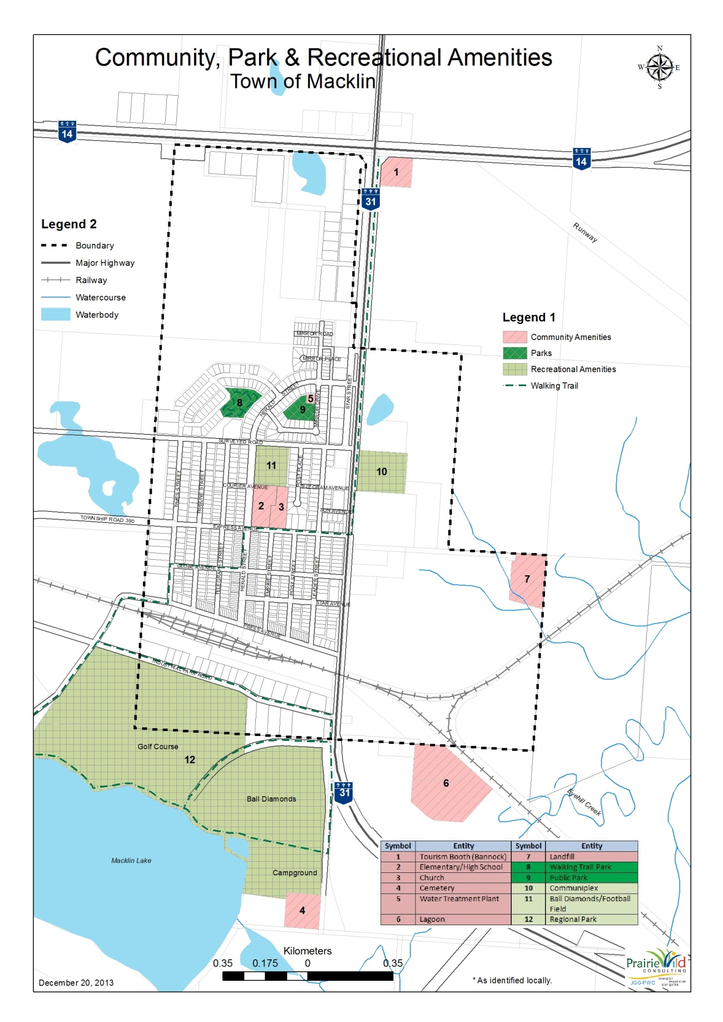
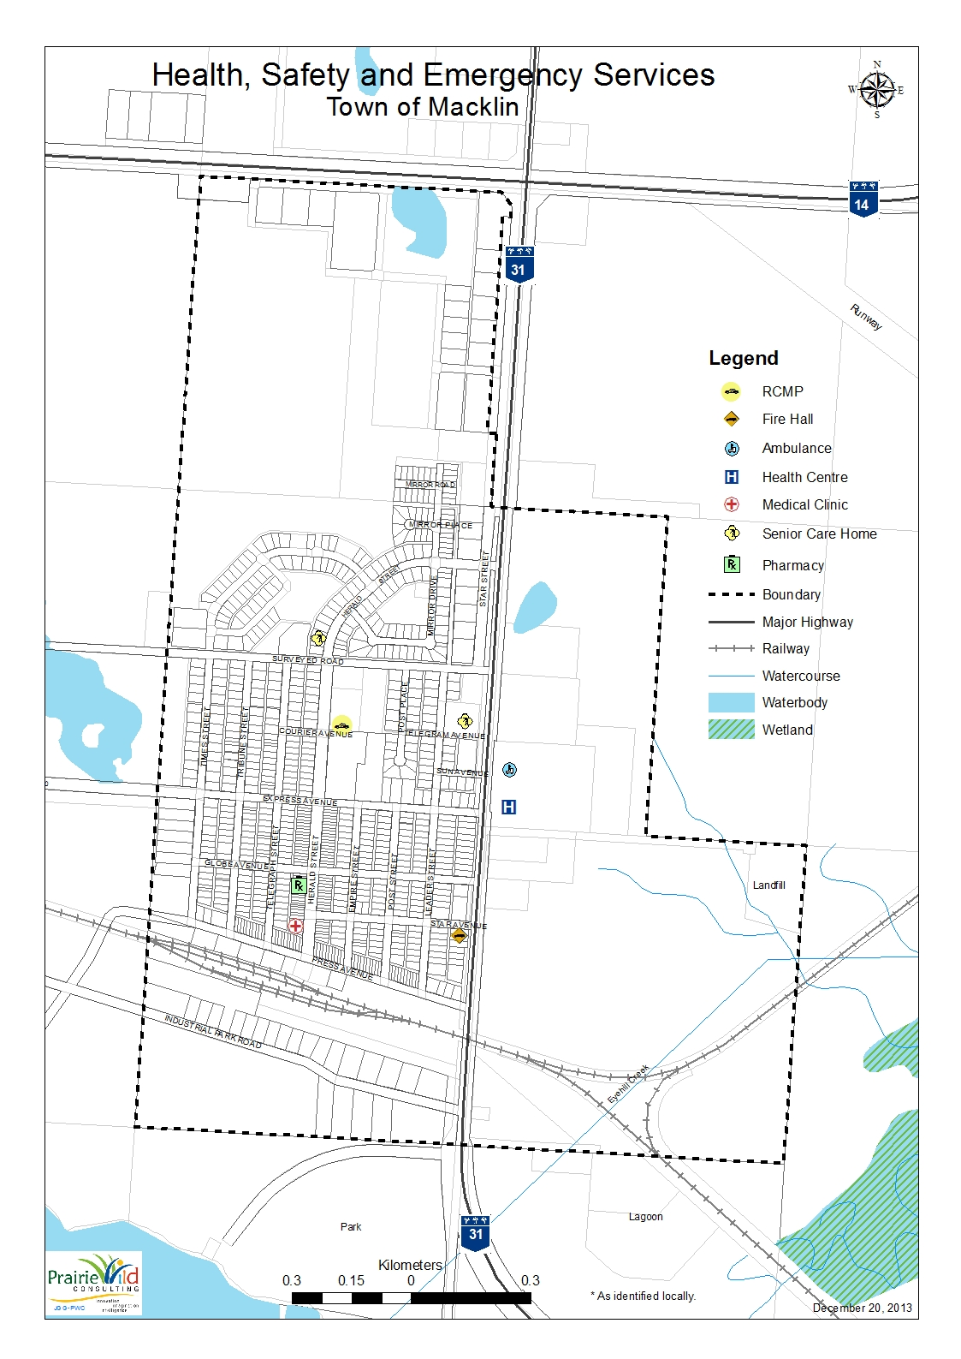
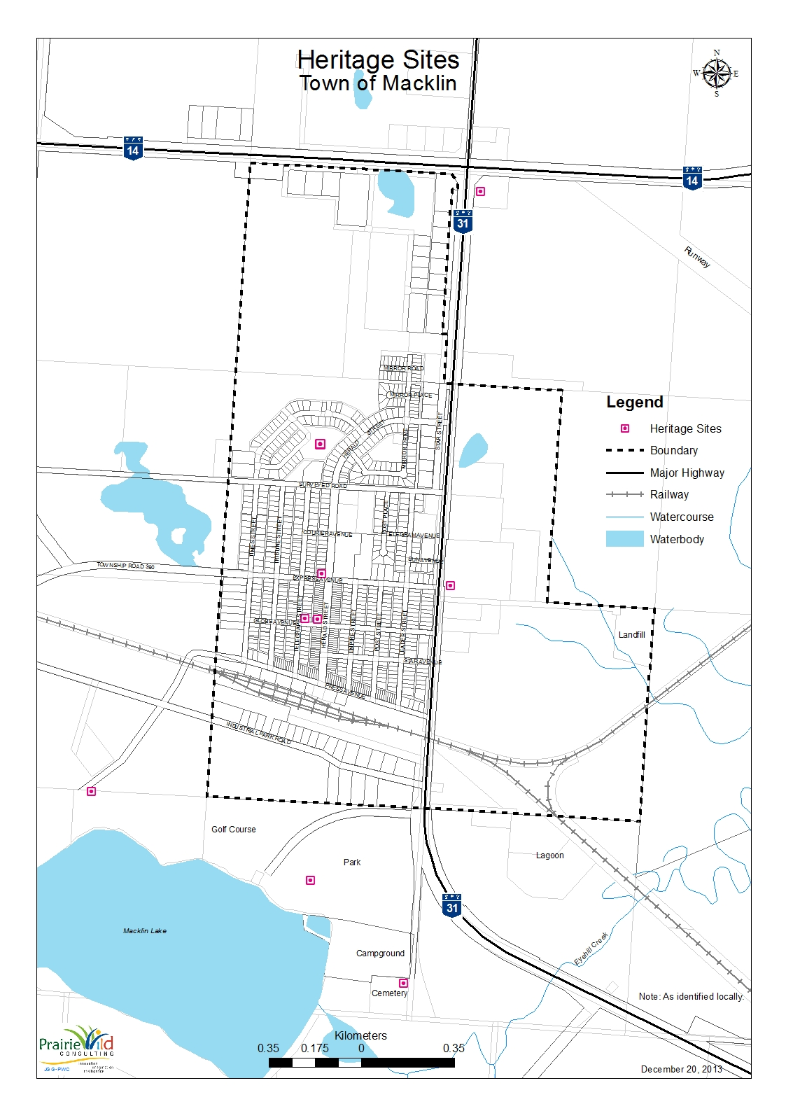
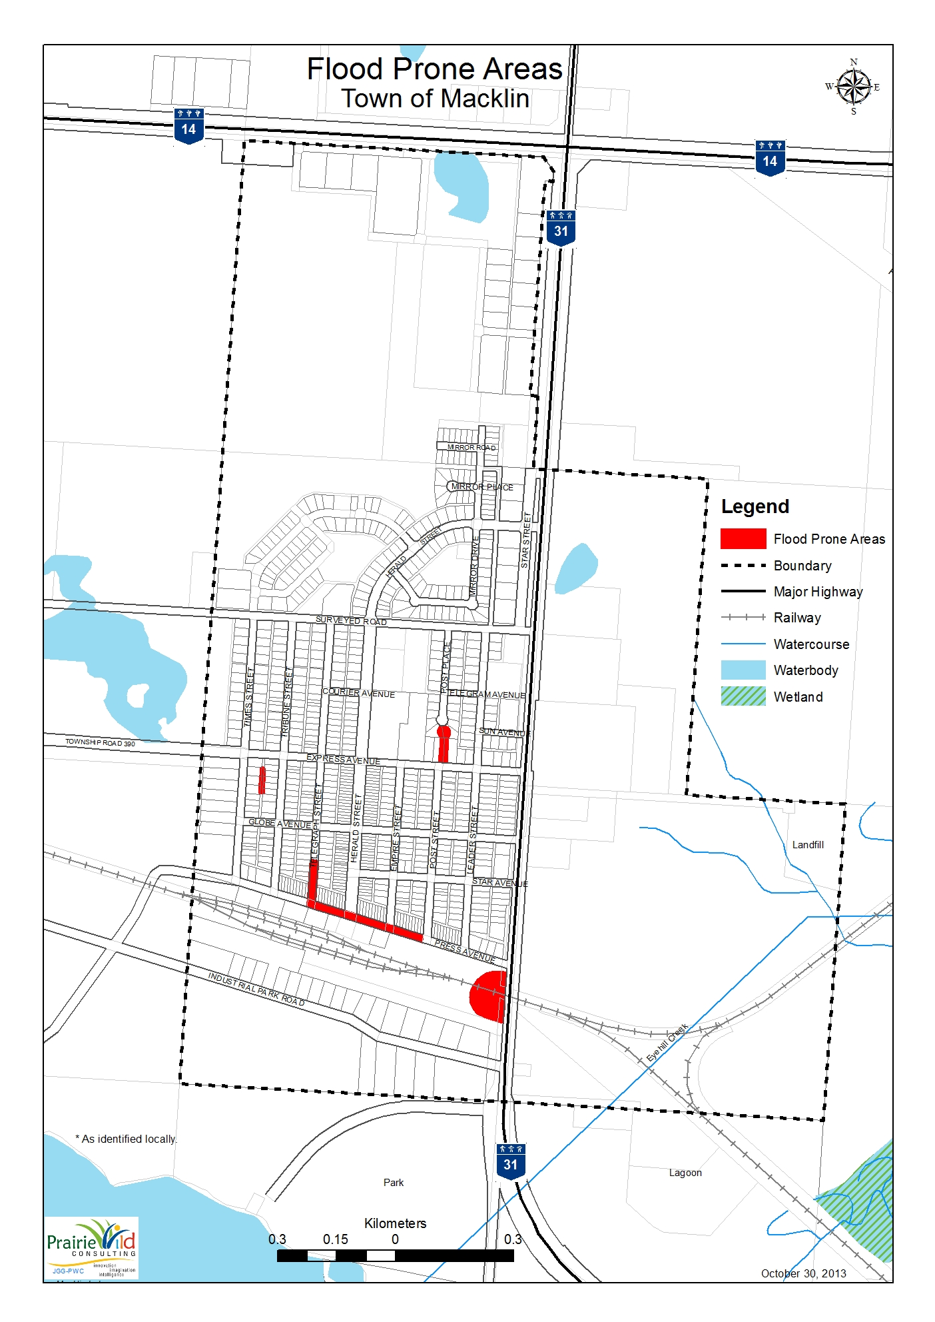
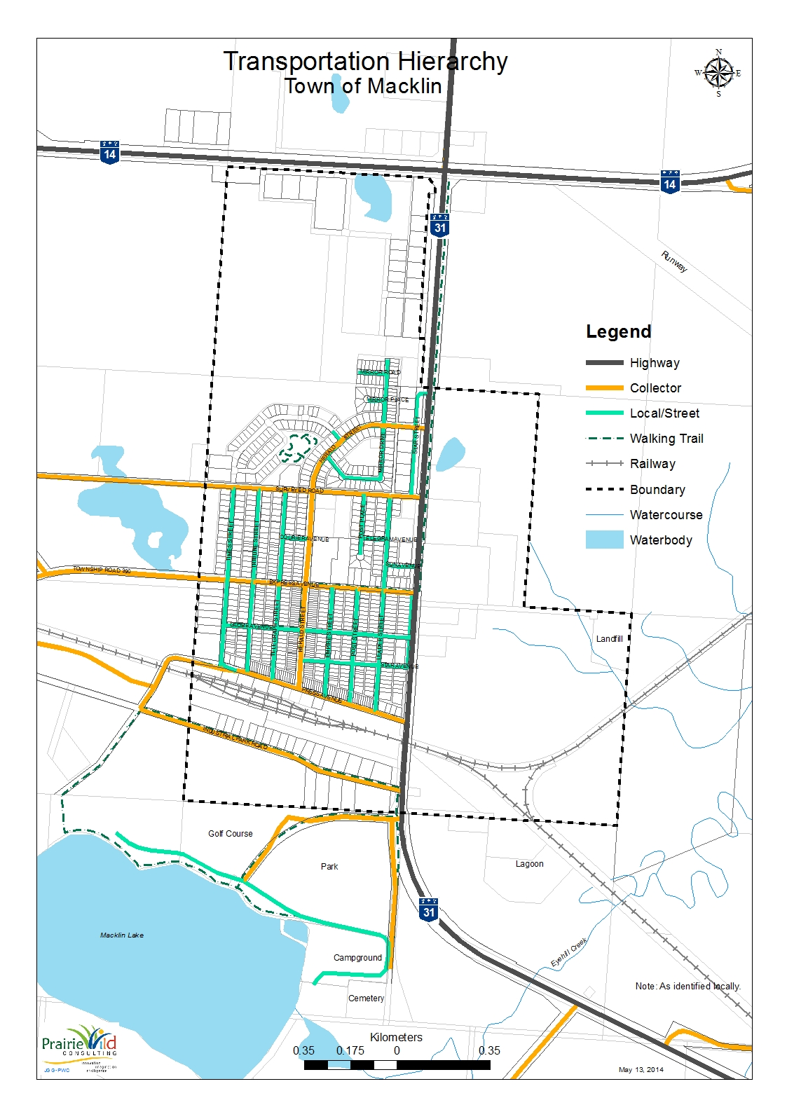
Amendment Bylaw No. XX-2016
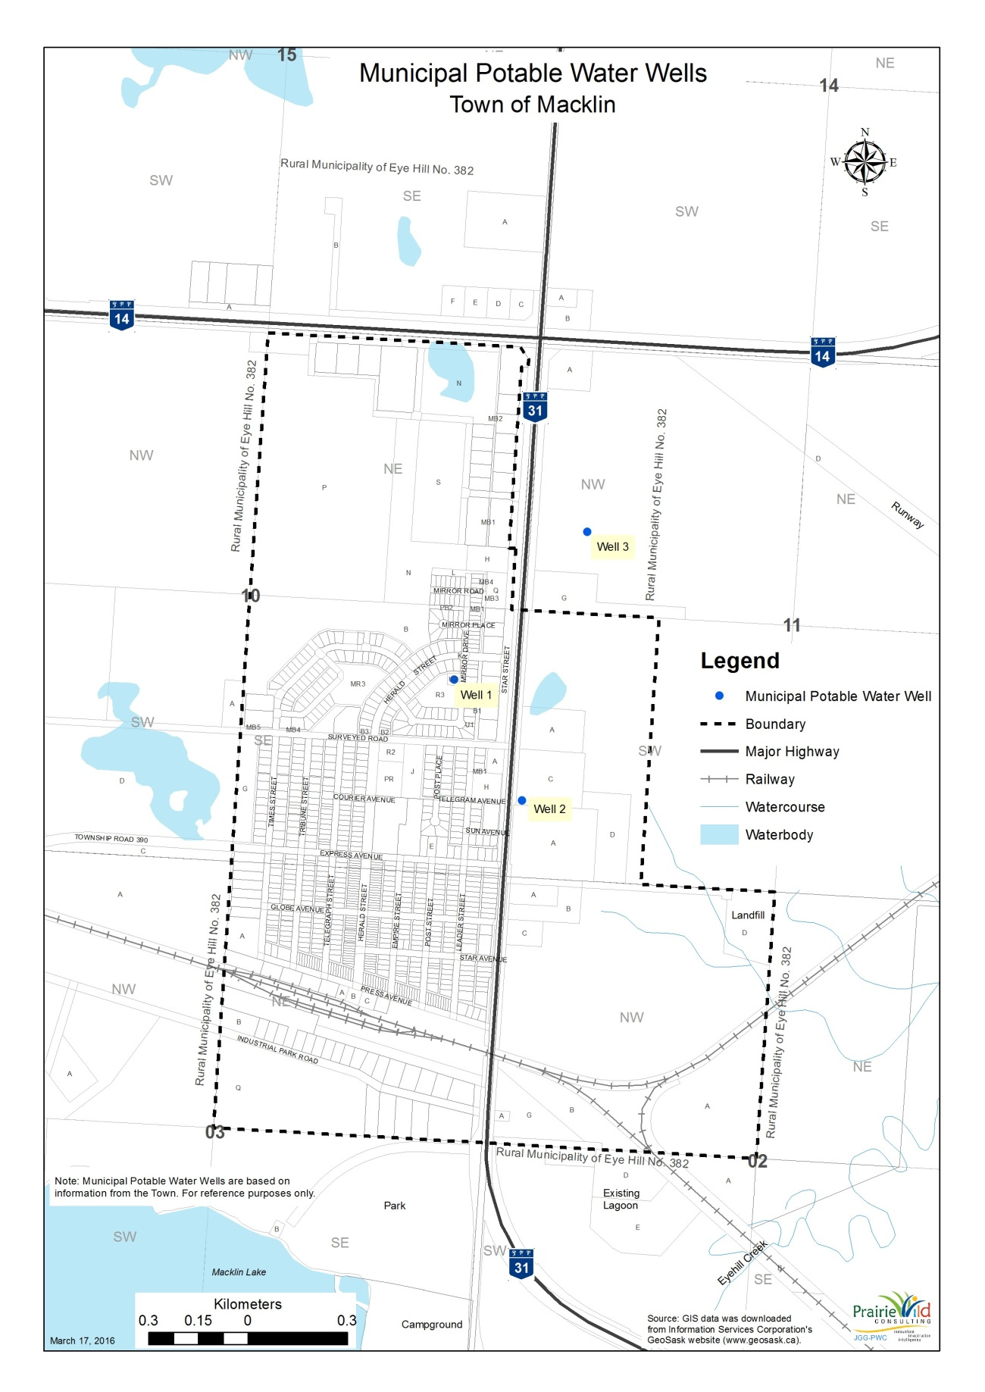
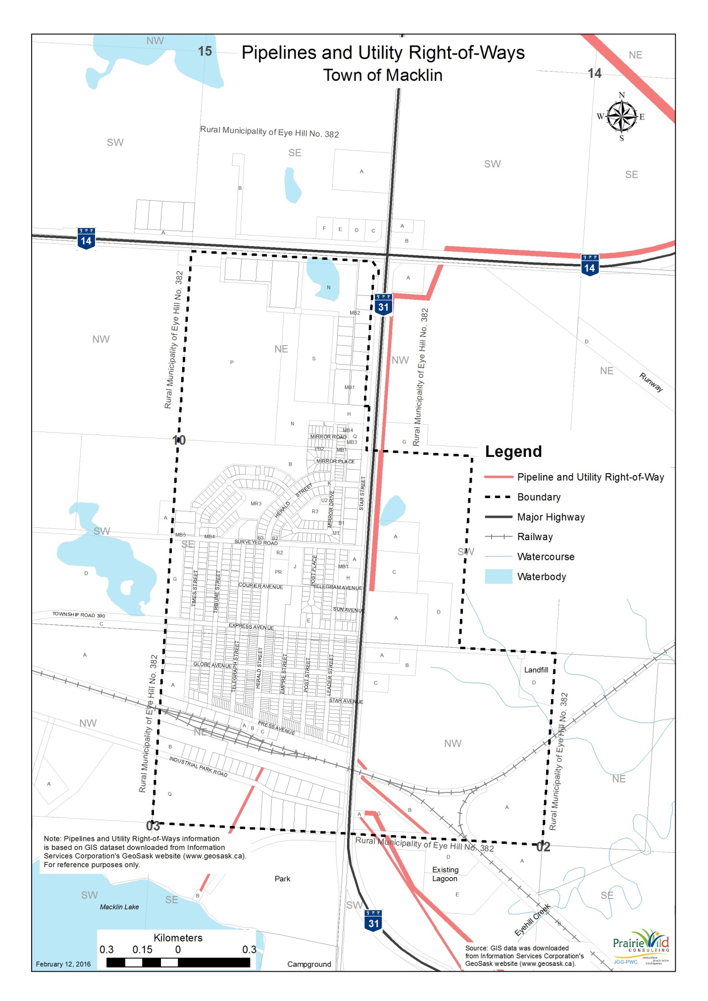
APPENDIX “C” – TOWN OF MACKLIN INFRASTRUCTURE CAPACITIES
 | EXAMPLE | Town/Village of
CONNECTIONS | 98 | 550
WATER SUPPLY | Aquifer: 68 Million gallons. 60,000 gallon treated water reservoir. Pumping rate 30 gal/min | Aquifer: 105 million annually  500,000 treated water reservoir  Pumping 300 gallons per minute
SURPLUS CAPACITY  (PERCENTAGE / POPULATION) | 50 % or 100 people | 61%
ANNUAL WATER TREATMENT | 5 million gallons | 41 million gallons
SEPTIC TREATMENT | 2 cell lagoon, 1 treatment, 1 storage | 2 cell lagoon  1 treatment  1 storage
SURPLUS CAPACITY  (PERCENTAGE / POPULATION) | 35 % or 225 people | New lagoon being built in 2011
SOLID WASTE MANAGEMENT  (TRANSFER STATION / LANDFILL life expectancy) | Shared landfill with RM; 75 year expectancy  (please indicate if within Municipal boundary) | Transfer Station  WYWRA (West Yellowhead Waste Resource Authority)
CURRENT ENGINEERING STUDY  (YES/NO; YEAR) | Yes; 1998 | No
PUBLIC WELLS OR WELL-HEADS | Yes /No (please indicate location on Town/Village map) | Yes
WATER LINES / UTILITIES | Yes /No (please indicate location on Town/Village map) | Full Service to full community
LAGOONS | Yes/No (please indicate location on map) | Yes (1)
CEMETERY | Yes/No (please indicate location on map) | Yes (1) in RM

Census of Canada (2011). Community Profiles. Ottawa, Ontario. Accessed March 23, 2013 from (http://www12.statcan.gc.ca/census-recensement/2011/dp-pd/prof/index.cfm?Lang=E)
Town of Macklin (2006). History. Accessed March 23, 2013 from (http://www.macklin.ca/history.htm)
Ibid.
Census of Canada (2011). Community Profiles. Ottawa, Ontario. Accessed March 23, 2013 from (http://www12.statcan.gc.ca/census-recensement/2011/dp-pd/prof/index.cfm?Lang=E)
Census of Canada (2011). Community Profiles. Ottawa, Ontario. Accessed March 23, 2013 from (http://www12.statcan.gc.ca/census-recensement/2011/dp-pd/prof/index.cfm?Lang=E)
Census of Canada (2007). 2006 Community Profiles. Ottawa, Ontario. Accessed January 14, 2011 from (http://www12.statcan.gc.ca/census-recensement/2006/dp-pd/prof/index.cfm?Lang=E)
Ibid.
Ibid.
Census of Canada (2007). 2006 Community Profiles. Ottawa, Ontario. Accessed January 14, 2011 from (http://www12.statcan.gc.ca/census-recensement/2006/dp-pd/prof/index.cfm?Lang=E)
Census of Canada (2007). 2006 Community Profiles. Ottawa, Ontario. Accessed January 14, 2011 from (http://www12.statcan.gc.ca/census-recensement/2006/dp-pd/prof/index.cfm?Lang=E).
Ibid.
Census of Canada (2007). 2006 Community Profiles. Ottawa, Ontario. Accessed January 14, 2011 from (http://www12.statcan.gc.ca/census-recensement/2006/dp-pd/prof/index.cfm?Lang=E)
Ibid.
FireSmart principles and resources can be found at the following website: http://www.environment.gov.sk.ca/firesmart
Town of Macklin (2006). History. Accessed March 23, 2013 from (http://www.macklin.ca/history.htm)

